Explanatory document to Augstsprieguma tīkls, Elering and Litgrid proposal for Baltic balancing capacity market pursuant with Article 33(1) and Article 38(1) of the Commission Regulation (EU) 2017/2195 of 23 November 2017 establishing a guideline on electricity balancing

Table of Contents
1. Introduction 2
2. Purpose 2
3. Background 2
4. Dimensioning 2
5. Products 3
5.1. Linkage of bids 4
6. Resources 5
6.1. Prequalification 6
7. Capacity bid submission and procurement 6
7.1. Transfer of obligations 7
7.2. Additional rules for Mandatory energy bids 7
8. Algorithm 7
8.1. FCR process 7
8.2. FCR procurement algorithm 8
8.3. FRR process 9
8.4. FRR balancing capacity procurement algorithm 10
8.5. CZC allocation for balancing capacity 10
9. Settlement 10
9.1. TSO-BSP settlement 10
9.2. TSO-TSO settlement 12
9.3. Congestion income 12

- Introduction
The document at hand aims to further explain the proposal for the establishment of common and harmonized rules and processes for the exchange, sharing and procurement of aFRR and mFRR balancing capacity in accordance with article 33(1) and Article 38(1) of the Commission Regulation (EU) 2017/2195 of 23 November 2017 establishing a guideline on electricity balancing /hereinafter referred to as „EBGL“) by Elering, AST and Litgrid. This proposal is hereinafter referred to as the „Proposal“, and Elering, AST and Litgrid are hereinafter collectively referred to as the „Baltic TSOs“.
- Purpose
The purpose of the FCR and FRR balancing capacity markets is to ensure the availability of relevant reserves according to the dimensioning process in the Baltic TSOs and Baltic LFC block, and the regional security of supply in general.
The establishment on the common balancing capacity market is imperative to ensure sufficient volume of balancing capacity reserves within the 3 Baltic bidding zones with the highest possible welfare through the optimization of CZC between the balancing capacity and the day-ahead markets. CZC allocation is a crucial part of the Baltic balancing capacity market without which Baltic countries are unable to fulfill their reserve requirements.
- Background
After synchronization with CESA, the three Baltic bidding zones collectively form the Baltic LFC block in 2025 Q4. From the establishment of the Baltic LFC Block, a balancing capacity procurement process is crucial in order to ensure sufficient amount of reserves that shall be used to balance the system. However, the Baltic TSOs foresee establishing the common Baltic balancing capacity market even before the operation of the Baltic LFC block in order to prepare for synchronization and better balance the Baltic power systems even before disconnecting from the Russian/Belarussian power system.
The Baltic TSOs foresee organizing a joint FRR dimensioning process, which will result in FRR required volumes per LFC area (equal to a bidding zone) and the LFC block. The outputs of the common dimensioning process shall be used as inputs to the balancing capacity procurement algorithm. The dimensioning process and its output is heavily driven by the Baltic external HVDC connections, which, due to their size, serve as the reference incidents for Estonia and Lithuania.
The Baltic TSOs have conducted a market test to evaluate the amount of resources available which would be able to provide FCR and FRR products and concluded that the supply of FRR capacity in each country is relatively low compared to the identified reference incidents (650 MW in Estonia, 700 MW in Lithuania). Therefore, in the Proposal, in addition to exchange of balancing capacity, a heavy emphasis is put on sharing of reserves, in order to deliver sufficient amount of FRR capacity to all Baltic BZs. It is agreed between the Baltic TSOs that due to the imbalance between balancing capacity available in a particular Baltic BZ, and the FRR reserve requirement for that respective BZ, all balancing capacity which is procured between the Baltic countries can be considered as shared. This means that a single balancing capacity resource is able to contribute to fulfilling the reserve requirements of all three Baltic bidding zones with the same asset. However, also exchange is foreseen due to unequal balancing reserve requirements in the Baltic BZs.
- Dimensioning
The Baltic TSOs apply a dimensioning process which relies on both stochastic and deterministic analysis. Main contributors to the stochastic analysis shall be variations in load and intermittent generation outputs and to the deterministic analysis the reference incidents. For reference incidents the Baltic external HVDC links play the most important role.
The FCR dimensioning is performed and provided for the whole Continental Europe synchronous area by CESA System Frequency working-group after the Baltic power systems are synchronized with CESA. Baltic LFC areas receive the FCR capacities from the same process. Estimated FCR capacities for Baltic LFC areas is provided in the Baltic LFC concept document.
 | Pre-synchronization model | Post-synchronization model (LFC Block operation)
FCR | Not used | Common CESA methodology
FRR | FRR dimensioning is the task on the Baltic TSOs. The Baltic FRR dimensioning output defines the necessary amount of aFRR and mFRR (aFRR and mFRR combined is considered FRR) both on the bidding zone level as well as requirements for the three Baltic bidding zones as a whole.

The Baltic TSOs foresee a process which combines both long-term and short-term processes for FRR dimensioning. Long-term dimensioning is determined for a long-time horizon, such as a year in advance which relies on the fundamental characteristics of the power system. The long-term dimensioning process shall be accompanied by a short-term dimensioning process, which takes into account the specific state of the power system for the FRR dimensioning period, for example, including specific knowledge on HVDC maintenance and other critical parameters such as RES forecast. The dimensioned FCR and FRR amounts are indicatively estimated in the Baltic LFC concept document. Baltic TSOs have prepared Baltic LFC block FRR dimensioning forecast for 2024-2031. Estimated amounts of balancing capacity reserves for Baltics as well as shares of responsibility of each bidding zone and estimated amounts of balancing capacity reserves which will be covered by TSO resources (Kiisa power plant in Estonia and planned AST Battery Energy Storage System in Latvia) and planned resources of Battery storage operator in Lithuania are shown in the figure below:
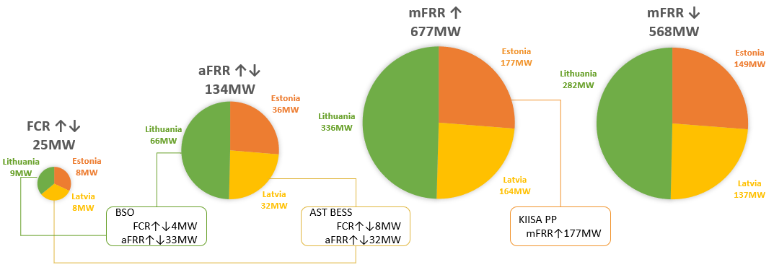
- Products
Baltic Balancing market foresees to use the standard FCR, aFRR and mFRR capacity products as described in the Proposal. The BSP must be prequalified by the Connecting TSO to participate in the Baltic capacity market.
Main aspects for the standard FCR product:
- Minimum bid quantity is 1 MW and the granularity is 1 MW.
- Maximum bid size is limited by the prequalified BSP resources eligible for participation in the Baltic balancing market.
- Price is in EUR/MW and it is positive or zero, limited up to the maximum possible bid price in the day-ahead market in Baltic region converted, if needed, to Euros per megawatt per MTU.
- Validity period is for one single market time unit.
- Block bid linkage is allowed.

Main aspects for the standard FRR product:
- Minimum bid quantity is 1 MW and the granularity is 1 MW.
- Maximum bid size is limited by the prequalified BSP resources eligible for participation in the Baltic balancing market.
- Regarding product divisibility:
  - aFRR – only divisible bids are allowed.
  - mFRR – divisible bids are allowed as default bids. Indivisible or partly divisible bids are allowed based on the BSP prequalification.
- Price is in EUR/MW and it is positive or zero, limited up to the maximum possible bid price in the day-ahead markets in Baltic region converted, if needed, to Euros per megawatt per 15-minute period.
- Validity period is for one single market time unit.
- Block bid linkage, joint linked up-and-down bids and exclusive linkage is allowed.
  - Linkage of bids
Block linkage
This kind of linkage refers to the linkage between bids with the same product, volume, direction and price of consecutive market time units. If one of those bids are accepted, then all linked bids are accepted too. Block bid linkage is limited only by those MTUs for which market is run (maximum amount of MTUs included in linkage is equal to the number of MTUs in an auction period). The possible combinations with other type of linkage for FRR product are described in table below.

Joint linked up-and-down bids
This linkage corresponds to an upward and downward bid linkage in the same market time. Upward and downward bids can be in different volumes but the ratio between joint up links cannot be higher than 2. This means, that for example, for every 2 MW upwards BSP must bid at least 1 MW downward and vice versa. Both linked bids must be either accepted or rejected. Both linked up-and-down bids are accepted in full amount only. The possible combinations with other type of linkage for FRR product are described in table below.

Exclusive bids
An alternative way to submit single bids with the possibility to use links to submit a bid curve where only one bid of the group of bids constituting the bid curve can be selected. This give BSPs great flexibility in presenting their actual cost structure in their bidding. All kinds of links between different units of a portfolio can be converted into a bid curve for a certain MTU. However, if the option of bid curve is used, the BSP foregoes the opportunity to use block bids. Cross FRR product linkage is allowed.
Exclusive bids can be combined with joint linked upward- and downward bids, where only one pair of bids can be selected in the group of bid pairs. Exclusive linkage cannot be paired with the block linkage.

Combination of different linking types
The possible combinations with other type of linkage are described in below.

Allowed FRR linkage combinations:
Case | Divisibility | Block | Joint linked up-ad-down | Exclusive | Description
D | Yes | No | No | No | Singe divisible bid
- | No | No | No | No | Singe indivisible bid
DB | Yes | Yes | No | No | Block of divisible bids
B | No | Yes | No | No | Block of indivisible bids
DL | Yes | No | Yes | No | Divisible joint linked up-and-down bid
L | No | No | Yes | No | Indivisible joint linked up-and-down bid
DBL | Yes | Yes | Yes | No | Block of divisible joint linked up-and-down bids
BL | No | Yes | Yes | No | Block of indivisible joint linked up-and-down bids
DE | Yes | No | No | Yes | Divisible exclusive bids
E | No | No | No | Yes | Indivisible exclusive bids
DLE | Yes | No | Yes | Yes | Divisible exclusive group joint up-and-down linkage
LE | No | No | Yes | Yes | Indivisible exclusive group joint up-and-down linkage

Not allowed FRR linkage combinations:
Case | Divisibility | Block | Joint linked up-ad-down | Exclusive | Description
1 | Yes | Yes | No | Yes | Block bids cannot be part of an exclusive group.
2 | No | Yes | No | Yes
3 | Yes | Yes | Yes | Yes
4 | No | Yes | Yes | Yes
- Resources
Baltic balancing capacity market design does not foresee exchange or sharing of reserves capacity with neighboring areas outside Baltic bidding zones from the beginning of market operation, thus all dimensioned amounts of each type of reserves (FCR, aFRR and mFRR) shall be covered by reserve resources located in three Baltic bidding zones. Considering limited amount of resources in Baltics now and in near future, which was indicated in the market test results conducted by Baltic TSOs in 2021, Baltic TSOs understand that in the situation with limited resources in Baltics and due to uncertainty brought by introduction of new types of reserves in the Baltic region, balancing capacity market design shall support usage of all possible available resources in Baltics – in terms of location, type (generation, consumption), size, composition (single technical units and groups), and ownership.

  - Types of resources
In order to gain as much flexibility for usage of resources as possible, Baltic balancing capacity market design distinguishes between two types of reserves in terms of their handling for optimization – primary and back-up resources.
Primary resources are reserves which shall be used under normal conditions, without any special restrictions, to cover FCR and FRR reserve requirements in Baltic bidding zones. All bids provided by Baltic balancing capacity market participants from reserve resources located in any of Baltic bidding zones, shall be used as primary resources.
Back-up resources can only be used in the case it is not possible to cover FCR and FRR reserve requirements in Baltic bidding zones by primary reserves even after increase of CZC to its maximum level. There could be resources owned, procured or in other way available for Baltic TSOs, which may be used as back-up resources.
Use of resources available for TSOs as primary or back-up resources is determined by each TSO in accordance with European and National regulations and guidelines.
  - Prequalification
Harmonized principles for Reserve Providing Unit (RPU) and Reserve Providing Group (RPG) prequalification in the Baltic LFC block have been agreed upon, defining conditions for technical conformity among reserve providers, and establishing testing procedures. The harmonized principles for Baltic LFC reserve prequalification are published on each respective Baltic TSO's web page.
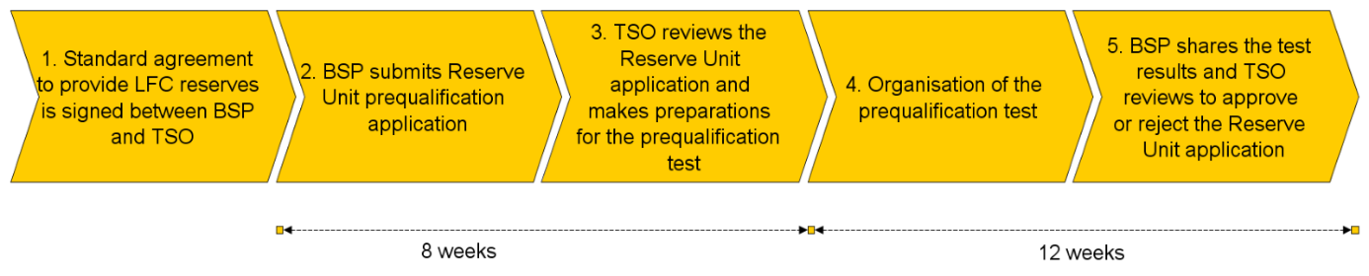
Figure 1 Overview of prequalification process
Only those RPUs and RPGs which are prequalified and contains unique technical units (such technical units, which are not used in any other prequalified RPU or RPG already determined to be eligible to participate in the Baltic balancing market) shall be eligible to participate in the Baltic balancing capacity market.
Further rules for prequalification of RPUs and RPGs and determination of eligible RPUs and RPGs for participation in the Baltic capacity market are subject to nationally set terms and conditions.
- Capacity bid submission and procurement
Bid submission for daily auctions
Baltic balancing capacity market design foresees organization of daily auctions to procure required reserves for next day each market time periods. Bids in accordance with Baltic capacity products for each type of reserves (FCR, aFRR and mFRR) can be submitted by BSPs for each daily auction starting from capacity bid submission opening time until respective reserve type bid submission closing time (Figure 2). Submitted bids can be updated or withdrawn until bid submission closing time. After this time bids can no longer be changed and are considered firm.
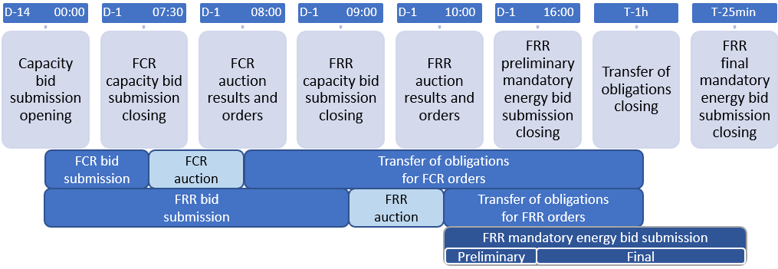
Figure 2. Handling of bids and orders
Orders
As a result of auctions, orders for capacity reserves with obligation for BSP to ensure reserves will be provided. Orders will contain information about location (bidding zone), reserve unit, type of reserves and amount of reserves. Information about reserve unit may not be included in the order initially, if this information is not provided in the bid, but shall be provided in the order by BSP prior to the gate closer time for transfer of obligations.
  - Transfer of obligations
After receiving of order for balancing capacity, due to unavailability of resources or other reasons, BSP may transfer obligations provided in the order. Obligations may be transferred until transfer of obligation closing time (Figure 2). Obligations may be transferred only within the bidding zone to which order has been provided. Obligations may be transferred to another reserve unit of the same BSP (if information of the reserve unit is provided in the order), or to another BSP. In any case, compliance of the BSP and/or reserve unit with prequalification requirements shall be ensured and will be monitored.
  - Additional rules for Mandatory energy bids
FRR reserves specified in the order shall be submitted to the Connecting TSO in form of respective balancing energy product and in accordance with Baltic balancing rules and corresponding National terms and conditions. Such bids will be considered as mandatory bids in the energy market and there will be monitoring for its presence and availability organised by Connecting TSO.
- Algorithm
There will be separate procurement processes for FCR and FRR. The FCR procurement process is organized before the FRR process which allows the market participants to use the outcome of the FCR process in the FRR process as input. The FCR and FRR processes each have their own individual procurement functions which feature different restrictions. Within the FRR process, the market is cleared simultaneously for both aFRR and both mFRR products, optimizing the CZC usage for all markets.
First the procurement function for FCR is ran and results are communicated to the BSPs. After, the FRR bids are collected and procurement function for both aFRR and mFRR is run as a single optimisation, results will be communicated to the BSPs as stated in the Figure 2.
  - FCR process
The reserve capacity bid closure time for the submission of FCR bids by BSPs to the connecting TSO for the next day shall be no later than 7:30 (EET).

Each TSO shall submit following information as an input to FCR procurement optimization function run:

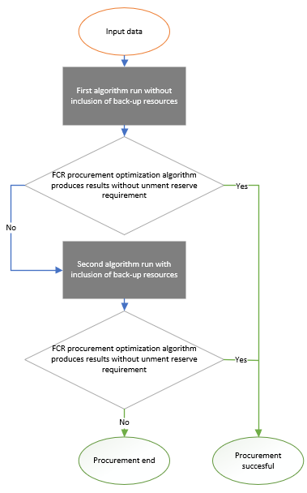
- All FCR balancing capacity bids received from primary and back-up resources;
Figure 3. FCR process
- Reserve requirements of FCR reserve capacity in accordance with dimensioning rules of the CESA System Frequency working-group;
- Minimum volume of balancing capacity to be procured in each bidding zone, if applicable;

Procurement optimization function has two runs (Figure 3): first run without inclusion of bids marked as back-up resources and if the first run does not satisfy the reserve requirements that was provided by the TSOs, the second run involving back-up bids is ran. The second optimization run shall be considered final, if the algorithm provides results, regardless of fulfillment of TSOs’ reserve requirements.

Each TSO shall publish the FCR procurement results and submit to respective BSPs the FCR capacity order no later than 8:00 (EET).

  - FCR procurement algorithm
The FCR procurement algorithm shall maximize the welfare of FCR procurement while fulfilling the required FCR capacity reserve requirements in the Baltic bidding zones and in Baltic LFC block. Because no CZC is to be allocated for FCR, in this process the forecast welfare for the exchange of energy is not considered.

  - FRR process
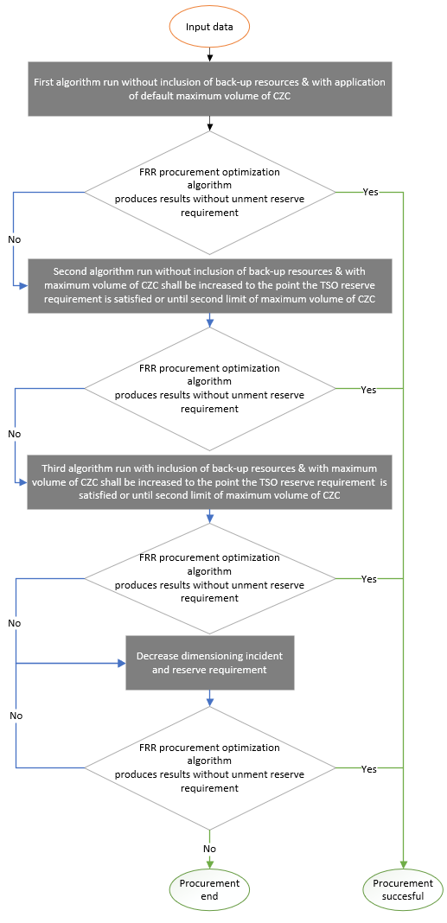
The reserve capacity bid closure time for the submission of mFRR and aFRR capacity bids by BSPs to the connecting TSO for the next day shall be no later than 9:00 (EET).
Figure 4. FRR process

Each TSO shall submit following information as an input to FRR procurement optimization function run:
- All FRR balancing capacity bids received from primary and back-up resources.
- Reserve requirements for all 3 Baltic bidding zones: minimal aFRR upward, minimal aFRR downward, total FRR upward, total FRR downward in accordance with dimensioning rules;
- Reserve requirements for each Baltic bidding zone: aFRR upward, aFRR downward, total FRR upward, total FRR downward in accordance with dimensioning rules in Baltic LFC block;
- Minimum volume of balancing capacity to be procured in each bidding zone, if applicable;
- Cross-zonal capacities available for allocation for FRR exchange and sharing in accordance with default and increased percentage limits defined in Article 5(1) of the Methodology for market-based capacity allocation;
- Total cross-zonal capacities available for the combination of allocation for FRR exchange and sharing and for the exchange of energy;
- The forecasted market value of cross-zonal capacity for each bidding zone border in the day-ahead market timeframe defined in accordance with Methodology for market-based capacity allocation;
Procurement optimisation function has three runs as explained in (Figure 4). The first run is executed without inclusion of bids marked as back-up resources and application of cross-zonal capacity limits according to default maximum volume of cross-zonal capacity (Limit 1) in accordance with Methodology for market-based capacity allocation.
If the first run of the optimization does not provide results that satisfy the reserve requirements which was provided by the TSOs, the second run will follow. Second run of the algorithm will ensue without inclusion of back-up resources and with application of the second limit (Limit 2) of maximum volume of cross-zonal capacity in accordance with Methodology for market-based capacity allocation. In second run, the cross-zonal capacity is increased in a step-wise manner by increasing Limit 1 by 1% until Limit 2 until the reserve requirements of TSOs is satisfied or the increased maximum cross-zonal capacity limit is reached.
If the second run of the algorithm does not provide the results that satisfy the TSO reserve requirements, then the third run of the algorithm ensues. In third algorithm run the bids from back-up resources are included and the procedure of increasing the maximum cross-zonal capacity limit can be used. For the optimization, the cross-zonal capacity is increased in a step-wise manner until the reserve requirement of TSOs is satisfied or the cross-zonal capacity limit is reached. The third optimization run shall be considered final if the algorithm provides results, regardless of fulfillment of TSOs’ reserve requirement.
Each TSO shall publish the FRR procurement results and submit to respective BSPs the aFRR and mFRR capacity order no later than 10:00 (EET).
  - FRR balancing capacity procurement algorithm
The FRR balancing capacity procurement algorithm shall clear the market simultaneously for the four FRR products: aFRR up, aFRR down, mFRR up and mFRR down; while optimizing CZC allocation for the exchange balancing capacity, sharing of reserves and exchange of energy. The objective of the procurement algorithm shall be the maximization of the combination of forecast welfare on the day-ahead market and the actual welfare of the FRR market.
The mathematical representation of the balancing capacity procurement algorithm is represented in greater detail in the Explanatory document to Baltic CCR TSOs proposal in accordance with Article 41(1) of the Commission Regulation (EU) 2017/2195 of 23 November 2017 establishing a guideline on electricity balancing.
  - CZC allocation for balancing capacity
According to the welfare maximization objective of the algorithm, CZC shall be allocated for balancing capacity if the welfare of using CZC for balancing is higher than forecast welfare for using CZC for the exchange of energy. The mathematical expression of the welfares of the two markets is explained in detail in the Explanatory document to Baltic CCR TSOs proposal in accordance with Article 41(1) of the Commission Regulation (EU) 2017/2195 of 23 November 2017 establishing a guideline on electricity balancing.
- Settlement
  - TSO-BSP settlement

FCR price is single marginal price in Baltic areas.
Baltic TSOs are analyzing two options for FRR TSO-BSP settlement pricing. The principles are both based on the marginal pricing principle, where the clearing price of a balancing capacity product is the same in the set of uncongested bidding zones. The major difference between the two presented options is whether or not the value of CZC is taken into account in the balancing capacity price formulation. Another major difference is the definition of congestion, where in the first option, congestion in the balancing capacity market is defined as the situation where all the capacity that is allowed to be allocated to balancing capacity is done so, and in the second option congestion is defined as the situation where all the available CZC is used up by the combination of the balancing capacity market and the forecast exchange of energy.
Option 1.
The FRR price is formulated with a marginal pricing principle taking into account two major parameters – the price of the most expensive accepted bid and CZC congestion between bidding zones. In a single bidding zone, or a set of uncongested bidding zones, between which there is balancing capacity exchange or sharing, there shall be a single balancing capacity price per MTU and per balancing capacity product and direction which shall be equal to the most expensive accepted bid in that bidding zone or set of uncongested bidding zones.
In case congestion is detected between bidding zones, the formulated prices can diverge. Congestion is defined as a situation where 100% of the allowed CZC according to Baltic CCR TSOs proposal in accordance with Article 41(1) of the Commission Regulation (EU) 2017/2195 of 23 November 2017 establishing a guideline on electricity balancing. Article 5(1) for balancing capacity exchange or sharing is being utilized by balancing capacity market
The rule covering the need to have the same price across uncongested bidding zones is intended to ensure that, where there is a group of uncongested bidding zones, the price in each zone reflects the potential value of investment in additional FRR in each zone as a means of meeting the demand of the other zones in the group.
Example 1. No congestion  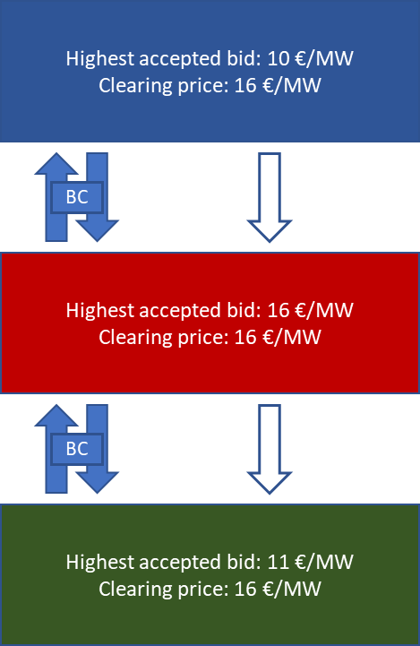  In case no congestion is identified, the clearing price in all bidding zones is equal to the price of the highest priced accepted bid. | Example 2. Congestion on single border  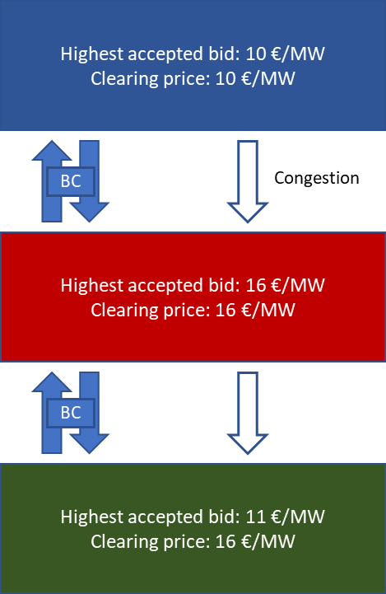  In case of congestion on one of the Baltic borders, the clearing price shall be equal in the bidding zones for which there is no congestion in between, but different for the one bidding zone which is separated by congestion.

Option 2.
The FRR price is formulated with a marginal pricing principle taking into account two major parameters – the price of the most expensive accepted bid and the price of CZC between bidding zones. In a single bidding zone, or a set of uncongested bidding zones, between which there is balancing capacity exchange or sharing, there shall be a single balancing capacity price per MTU and per balancing capacity product and direction which shall be equal to the most expensive accepted bid in that bidding zone or set of uncongested bidding zones and the price of CZC congestion between bidding zones.
In case congestion is detected between bidding zones, the formulated prices can diverge. Congestion is defined as a situation where 100% of the available CZC is being utilized by either the balancing capacity market, the forecast exchange of energy or a combination of the two.
A unique characteristic of the Baltic LFC block is the extensive sharing of reserves implemented between the bidding zones. The sharing shall cause situations where one balancing capacity product (for example, mFRR up) can be allocated on the same CZC in both directions at once. This aspect can cause circular calculations in balancing capacity pricing calculations. Therefore, it is established that in case a congestion is detected on CZC, the marginal price spreading shall not be possible on that CZC in either direction. In the direction opposite to the congested direction, CZC is taken into account when calculating marginal prices for the bidding zones. In the direction where congestion is detected, the CZC price shall be taken into account when calculating the import price. The CZC price shall be forecast difference of the day-ahead market prices of the relevant bidding zones as the output of the balancing capacity procurement algorithm. The day-ahead market price forecast model is further discussed in the Explanatory document to Baltic CCR TSOs proposal in accordance with Article 41(1) of the Commission Regulation (EU) 2017/2195 of 23 November 2017 establishing a guideline on electricity balancing.
Following, several cases are highlighted on how the clearing price for balancing capacity products is formed for each MTU in each Baltic bidding zone. The determination depends on the following factors always: the price of the most expensive accepted balancing capacity product bid in each bidding zone (if applicable), whether balancing capacity is exchanged or shared at a specific border in a specific direction and whether congestion is detected between bidding zones and in which direction it is detected.
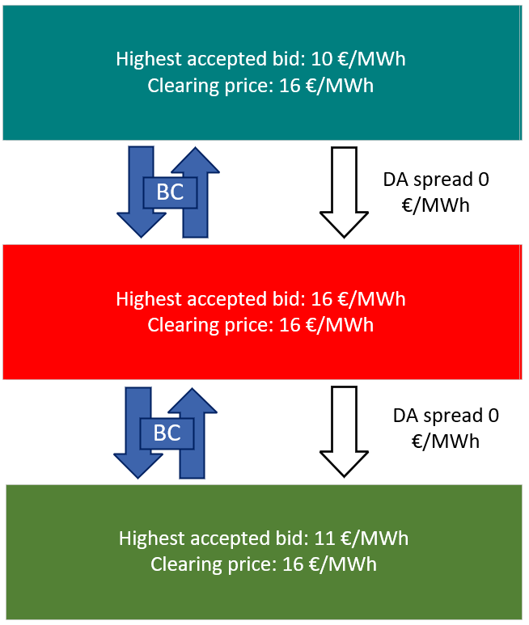
Example 1 – no congestion

In case no congestion is identified, the clearing price in all bidding zones is equal to the price of the highest priced accepted bid, assuming balancing capacity exchange takes place in both directions on all borders. If balancing capacity is not exchanged or shared in a specific direction, the marginal price shall not be identical in that direction.

Example 2 – congestion on a single border
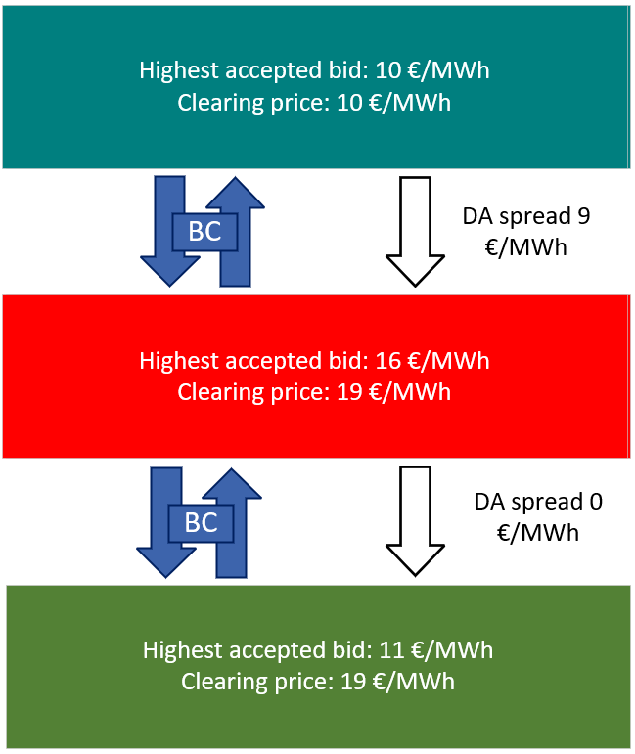
In case of congestion on one of the Baltic borders, the clearing price shall be equal in the bidding zones for which there is no congestion in between, but different for the one bidding zone which is separated by congestion. The forecast DA price spread is taken into account in the clearing price calculation.

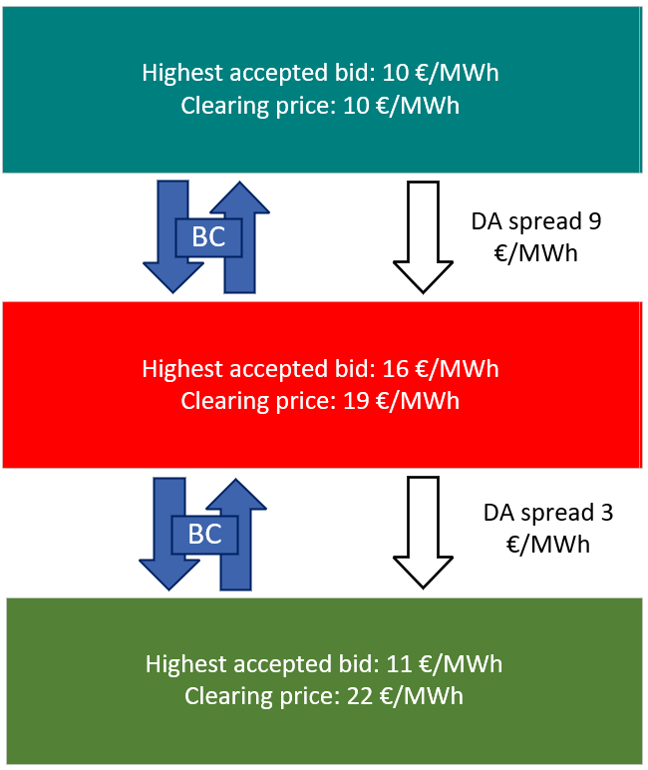
Example 3 – congestion on two internal consecutive CZC
In this case, congestion forecast on two borders between bidding zones. The forecast day-ahead market spread is taken into account on both borders.

Example 3 – congestion on two internal consecutive CZC
In this case, congestion forecast on two borders between bidding zones. The forecast day-ahead market spread is taken into account on both borders.
  - TSO-TSO settlement
As the Baltic bidding zones will form a single LFC block of operation and dimension the FCR and FRR reserve requirements jointly, the Baltic TSOs shall also follow a cost sharing arrangement in order to ensure fair contribution of reserve requirement fulfilment by all TSOs. Due to the extensive sharing arrangement of the Baltic TSOs, the costs of all procured reserves are shared under normal operating conditions. In the case of unmet TSO reserve requirements or overprocurement of reserves (meaning the overall procured amount of balancing capacity exceeds the block reserve requirements for the three Baltic bidding zones), due to insufficient availability of CZC, the TSOs engage in a more sophisticated cost-sharing calculation, which includes observation, which procured reserves are available to each individual bidding zone.
The basis of the 3 Baltic bidding zone TSO-TSO settlement are the outputs of the procurement algorithm, more precisely, the marginal prices of each balancing capacity product and procured amounts in each bidding zone, and the CZC allocation for each bidding zone and each balancing capacity product, for each MTU. Additionally, TSOs input to the joint dimensioning process is considered, the basic cost-sharing keys will be calculated according to how much each of the bidding zones contributed to the overall Baltic balancing capacity reserve requirements.
The cost-sharing methodology shall ensure that the financial contribution from each Baltic TSO represents which balancing capacity and at which price contributes to acquiring enough reserves to fulfill their reserve requirements from dimensioning.
  - Congestion income
Congestion revenue shall be generated and shared on bidding zone borders in the directions where congestion is detected and where CZC is allocated for balancing capacity products. The exact rules for generating and sharing congestion revenue are established in Baltic CCR TSOs proposal in accordance with Article 41(1) of the Commission Regulation (EU) 2017/2195 of 23 November 2017 establishing a guideline on electricity balancing.

[Elering website]; [AST website]; [Litgrid website]

