Explanatory document to Augstsprieguma tīkls, Elering and Litgrid proposal for Baltic balancing capacity market in accordance with Article 33(1) and Article 38(1) of the Commission Regulation (EU) 2017/2195 of 23 November 2017 establishing a guideline on electricity balancing

Table of Contents
1. Introduction 2
2. Purpose 3
3. Background 3
4. Exchange of balancing capacity and sharing of reserves 3
5. Dimensioning 5
6. Products 5
6.1. Linkage of bids 6
7. Resources 7
7.1. Types of resources 7
7.2. Prequalification 7
8. Capacity bid submission and procurement 8
8.1. Transfer of obligations 9
8.2. Additional rules for Mandatory energy bids 9
9. Algorithm 9
9.1. FCR process 9
9.2. FCR procurement algorithm 10
9.3. FRR process 10
9.4. FRR balancing capacity procurement algorithm 12
9.5. CZC allocation for balancing capacity 12
10. Fallback procedures 12
11. TSO-BSP settlement 13
12. Congestion income 14

- Introduction
The document at hand aims to further explain the proposal for the establishment of common and harmonized rules and processes for the exchange, sharing and procurement of aFRR and mFRR balancing capacity in accordance with article 33(1) and Article 38(1) of the Commission Regulation (EU) 2017/2195 of 23 November 2017 establishing a guideline on electricity balancing (hereinafter referred to as „EBGL“) by Elering, AST and Litgrid. This proposal is hereinafter referred to as the „Proposal“, and Elering, AST and Litgrid are hereinafter collectively referred to as the „Baltic TSOs“.
- Purpose
The purpose of the FCR and FRR balancing capacity markets is to ensure the availability of relevant reserves according to the dimensioning process in the Baltic TSOs and Baltic LFC block, and the regional security of supply in general.
The establishment on the common balancing capacity market is imperative to ensure sufficient volume of balancing capacity reserves within the 3 Baltic bidding zones with the highest possible welfare through the optimization of CZC between the balancing capacity and the day-ahead markets. CZC allocation is a crucial part of the Baltic balancing capacity market without which Baltic countries are unable to fulfil their reserve requirements.
- Background
After synchronization with CESA, the three Baltic bidding zones collectively form the Baltic LFC block in 2025 Q4. From the establishment of the Baltic LFC Block, a balancing capacity procurement process is crucial in order to ensure sufficient amount of reserves that shall be used to balance the system. However, the Baltic TSOs foresee establishing the common Baltic balancing capacity market even before the operation of the Baltic LFC block in order to prepare for synchronization and better balance the Baltic power systems even before disconnecting from the Russian/Belarussian power system.
The Baltic TSOs foresee organizing a joint FRR dimensioning process, which will result in FRR required volumes per LFC area (equal to a bidding zone) and the LFC block. The outputs of the common dimensioning process shall be used as inputs to the balancing capacity procurement algorithm. The dimensioning process and its output are heavily driven by the Baltic external HVDC connections, which, due to their size, serve as the reference incidents for Estonia and Lithuania.
The Baltic TSOs have conducted a market test to evaluate the amount of resources available which would be able to provide FCR and FRR products and concluded that the supply of FRR capacity in each country is relatively low compared to the identified reference incidents (650 MW in Estonia, 700 MW in Lithuania). Therefore, in the Proposal, in addition to exchange of balancing capacity, a heavy emphasis is put on sharing of reserves, in order to deliver sufficient amount of FRR capacity to all Baltic BZs. It is agreed between the Baltic TSOs that due to the imbalance between balancing capacity available in a particular Baltic BZ, and the FRR reserve requirement for that respective BZ, all balancing capacity which is procured between the Baltic countries can be considered as shared. This means that a single balancing capacity resource is able to contribute to fulfilling the reserve requirements of all three Baltic bidding zones with the same asset. However, also exchange is foreseen due to unequal balancing reserve requirements in the Baltic BZs.
- Exchange of balancing capacity and sharing of reserves
According to EBGL, two kinds of interactions regarding balancing capacity are possible across bidding zone borders. These interactions are exchange of balancing capacity and sharing of reserves, which are both defined in the Commission Regulation (EU) 2017/1485 of 2 August 2017 establishing a guideline on electricity transmission system operation, Article 3(2). Both of these allow the usage of cross-border cooperation in order to increase economic surplus but differ in how TSOs reserve requirements is satisfied.
Exchange of balancing capacity resembles in its functions the day-ahead market, in which a given sum of all TSO reserve requirements is fulfilled by choosing a number of BSP bids with the same total capacity, taking into account the geographical limitations and considerations of welfare maximization. In an arrangement where only the exchange of balancing capacity is possible, the total amount of procured balancing capacity is equal or greater to the sum of all TSO reserve requirements.

However, when sharing of reserves is allowed, this may not apply any more. In case an application allows for sharing of reserves to take place between TSOs, one megawatt of BSP supplied balancing capacity service can contribute to fulfilling to the demand of several TSOs. Thus, the establishment of a balancing capacity cooperation where sharing of reserves is allowed between TSOs, the gained benefit comes from several significant aspects: more efficient use of power system assets and optimized procurement of balancing capacity.

A simple illustration highlighting the key differences between the exchange of balancing capacity and sharing of reserves is highlighted in the image below, where TSO reserve requirements is satisfied only with exchange of balancing capacity in the case depicted in the top part, and satisfied via sharing of reserves in the bottom part.
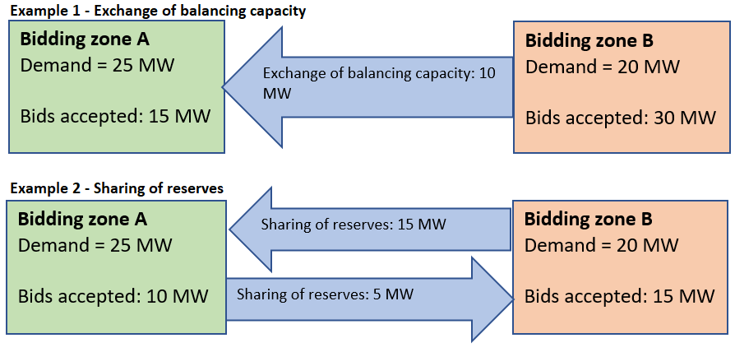
It can be observed that in the case where sharing of reserves is allowed, a significantly smaller amount of BSP resources is used to satisfy reserve requirement. However, as a downside, CZC needs to be allocated in both directions at once. The above means the balancing capacity market rules designed to accommodate only exchange of balancing capacity are usually not adequately detailed for the case when also sharing of reserves is allowed.

As of beginning of 2023, the major established cross-border balancing capacity procuring applications (such as CORE and Nordic CCRs) focus on the exchange of balancing capacity. The Baltic TSOs have analysed the situation of supply and demand in the Baltic region in a balancing capacity market test and determined that it imperative from the security of supply and the economic standpoint; to allow and enable the sharing of reserves in the Baltic region. The specific reasons are as follows:
- the available capacity of balancing capacity service provides is relatively small, due to the small size of the power systems;
- the reserve requirements are relatively high, deriving from the significant reference incidents caused by external HVDC links;
- the sharing of reserve schemes brings a significant benefit to the consumers, which is amplified in the unique Baltic environment, where a high reserve requirement must ultimately be supported by a relatively small consumption-base.
Taking the above into account, the Baltic TSOs foresee that sharing of reserves shall be the main purpose of allocating cross-zonal capacity. This will allow to ensure the Baltic countries to adequately ensure security of supply with a total of just about 800 MW of FRR up and 700 MW FRR down, while the sum of the three Baltic TSO’s demand is more than twice as much. In reality, there will be instances in the market where one can also observe exchange of balancing capacity, due to unequal reserve requirements in the Baltic bidding zones.
- Dimensioning
The Baltic TSOs apply a dimensioning process which relies on both stochastic and deterministic analysis. Main contributors to the stochastic analysis shall be variations in load and intermittent generation outputs and to the deterministic analysis the reference incidents. For reference incidents the Baltic external HVDC links play the most important role.
The FCR dimensioning is performed and provided for the whole Continental Europe synchronous area by CESA System Frequency working-group after the Baltic power systems are synchronized with CESA. Baltic LFC areas receive the FCR capacities from the same process. Estimated FCR capacities for Baltic LFC areas is provided in the Baltic LFC concept document.
 | Pre-synchronization model | Post-synchronization model (LFC Block operation)
FCR | Not used | Common CESA methodology
FRR | FRR dimensioning is the task on the Baltic TSOs. The Baltic FRR dimensioning output defines the necessary amount of aFRR and mFRR (aFRR and mFRR combined is considered FRR) both on the bidding zone level as well as requirements for the three Baltic bidding zones as a whole.

The Baltic TSOs foresee a process which combines both long-term and short-term processes for FRR dimensioning. Long-term dimensioning is determined for a long-time horizon, such as a year in advance which relies on the fundamental characteristics of the power system. The long-term dimensioning process shall be accompanied by a short-term dimensioning process, which takes into account the specific state of the power system for the FRR dimensioning period, for example, including specific knowledge on HVDC maintenance and other critical parameters such as RES forecast. The dimensioned FCR and FRR amounts are indicatively estimated in the Baltic LFC concept document. Baltic TSOs have prepared Baltic LFC block FRR dimensioning forecast for 2024-2031. Estimated amounts of balancing capacity reserves for Baltics as well as shares of responsibility of each bidding zone and estimated amounts of balancing capacity reserves which will be covered by TSO resources (Kiisa power plant in Estonia and planned AST Battery Energy Storage System in Latvia) and planned resources of Battery storage operator in Lithuania are shown in the figure below:
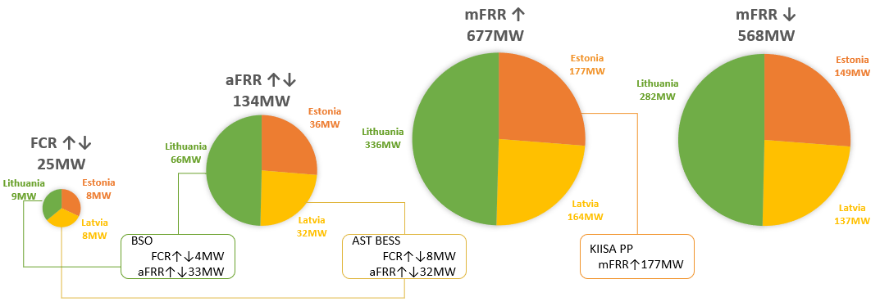
- Products
Baltic Balancing market foresees using the standard FCR, aFRR and mFRR capacity products as described in the Proposal. The BSP must be prequalified by the Connecting TSO to participate in the Baltic capacity market.
Main aspects for the standard FCR product:
- minimum bid quantity is 1 MW and the granularity is 1 MW;
- maximum bid size is limited by the prequalified BSP resources eligible for participation in the Baltic balancing market;
- divisible bids are allowed as default bids. Indivisible or partly divisible bids are allowed based on the BSP prequalification
- price is in EUR/MW/h and it is positive or zero, limited up to the maximum possible bid price in the day-ahead market in Baltic region ;
- validity period is for one single market time unit;
- block bid linkage is allowed;

Main aspects for the standard FRR product:
- minimum bid quantity is 1 MW and the granularity is 1 MW;
- maximum bid size is limited by the prequalified BSP resources eligible for participation in the Baltic balancing market;
- regarding product divisibility;
  - aFRR and mFRR – divisible bids are allowed as default bids. Indivisible or partly divisible bids are allowed based on the BSP prequalification;
- price is in EUR/MW/h and it is positive or zero, limited up to the maximum possible bid price in the day-ahead markets in Baltic region ;
- validity period is for one single market time unit;
- block bid linkage, joint linked up-and-down bids and exclusive linkage is allowed.
- Minimum resting time: minimum required duration between the end of acceptance and the following acceptance of the same balancing capacity bid;
- Maximum duration: maximum duration of the accepted balancing capacity bid.
The reason for setting the maximum limit for the balancing capacity bid price to be equal to the maximum possible bid price in the day-ahead market is because the reserve providing unit or reserve providing group withholds the energy that could be provided to the day-ahead market by delivering balancing capacity. Due to the withholding, opportunity costs arise which are taken into account when formulating the price for standard balancing capacity products. Therefore, the maximum possible price of a balancing capacity bid should be the same as the maximum possible price for a day-ahead market bid.
  - Linkage of bids
Block linkage
This kind of linkage refers to the linkage between bids with the same product, volume, direction, and price of consecutive market time units. If one of those bids is accepted, then all linked bids are accepted too. The accepted amount for a block bid shall be equal for all individual elements of the block. Block bid linkage is limited only by those MTUs for which market is run (maximum amount of MTUs included in linkage is equal to the number of MTUs in an auction period). The possible combinations with other types of linkage for FRR product are described in table below.
If block bids are accepted, it is possible that the clearing price in some individual market time units is not always equal or above the accepted block bid price, however per entire block, the average payout (€/MW) is guaranteed to be equal or higher than the bidding price of the block.
Block bids can be combined with joint linking of bids as well as exclusive grouping of bids.

Joint linked bids
This linkage corresponds to linking several bids in the same market time. The linked bid must both be accepted in equal amounts or rejected together. Joint linked bids can be used to link either aFRR up with aFRR down or mFRR up with mFRR down. Joint linked bids cannot be used to link aFRR products with mFRR products or bids which are not submitted for the same market time unit.
Joint linked bids can be combined with block bids as well as exclusive grouping of bids.

Exclusive bids
An alternative way to submit single bids with the possibility to use links to submit a set of exclusive bid groups, where only one of the groups can be selected by the algorithm. Exclusive groups can contain other types of complex bids – block bids and joint linked bids. This gives BSPs great flexibility in offering several competing products from the same asset, or when the supplier is limited in terms of the length of the delivery period, but not in terms of what time of day the delivery would be. The total number of exclusive groups which can be submitted is limited.

Quality limitations
BSPs can optionally specify these technical restrictions: minimum resting time and maximum duration for aFRR and mFRR balancing capacity bids. Bids with the same minimum resting time and maximum duration can be linked together, and this can be combined with both joint linked bids and exclusive bids. This cannot be applied for block bids. In the selection of bids, the technical restrictions are respected for the whole group of bids.

- Resources
Baltic balancing capacity market design does not foresee exchange or sharing of reserves capacity with neighbouring areas outside Baltic bidding zones from the beginning of market operation, thus all dimensioned amounts of each type of reserves (FCR, aFRR and mFRR) shall be covered by reserve resources located in three Baltic bidding zones. Considering limited amount of resources in Baltics now and in near future, which was indicated in the market test results conducted by Baltic TSOs in 2021, Baltic TSOs understand that in the situation with limited resources in Baltics and due to uncertainty brought by introduction of new types of reserves in the Baltic region, balancing capacity market design shall support usage of all possible available resources in Baltics – in terms of location, type (generation, consumption), size, composition (single technical units and groups), and ownership.
  - Types of resources
In order to gain as much flexibility for usage of resources as possible, Baltic balancing capacity market design distinguishes between two types of reserves in terms of their handling for optimization – primary and back-up resources.
Demand reduction resources are reserves that the TSO employs as a means of alleviating anticipated reserve supply deficiencies and ensuring the operational security of the Baltic electricity system. The balancing capacity amount to be procured in the Baltic balancing capacity market shall be reduced by the demand reduction reserves and cross-zonal capacity shall be allocated for sharing demand reduction resources between the Baltic TSOs. The volume of demand reduction resources will be assessed by the relevant TSO and subject to NRA approval based on the capability to satisfy TSO demand with balancing capacity bids from primary resources. Essentially, as the market grows and is observed to be capable of reasonably covering demand requirements, it is expected that demand reduction resources will not be used when TSO demand can be satisfied with primary resources. TSOs will not receive any renumeration for such resources, which shall not be priced.
Primary resources are reserves which shall be used under normal conditions, without any special restrictions, to cover FCR and FRR reserve requirements in Baltic bidding zones. All bids provided by Baltic balancing capacity market participants from reserve resources located in any of Baltic bidding zones, shall be used as primary resources.
Back-up resources can only be used in the case it is not possible to cover FCR and FRR reserve requirements in Baltic bidding zones by primary reserves even after increase of CZC to its maximum level. There could be resources owned, procured or in other way available for Baltic TSOs, which may be used as back-up resources.
Use of resources available for TSOs as primary or back-up resources is determined by each TSO in accordance with European and National regulations and guidelines.

Table of resource types
 | Primary resources | Demand reduction resources | Back-up resources
Ownership | BSP | TSO | TSO
Prequalification necessary | Yes | Yes | Yes
Participation in optimization rounds | 1a, 1b, 1c | 1a, 1b, 1c | 1c
Sets marginal price when selected last | Yes | 0 €/MW/h | No
Renumeration | Marginal price cost based | No | Operational cost based

  - Prequalification
Harmonized principles for Reserve Providing Unit (RPU) and Reserve Providing Group (RPG) prequalification in the Baltic LFC block have been agreed upon, defining conditions for technical conformity among reserve providers, and establishing testing procedures. The harmonized principles for Baltic LFC reserve prequalification are published on each respective Baltic TSO's web page.
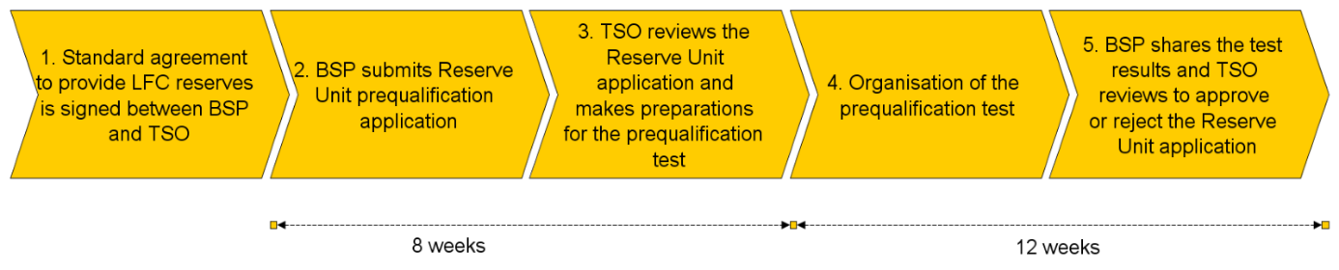
Figure 1. Overview of prequalification process
Only those RPUs and RPGs which are prequalified and contains unique technical units (such technical units, which are not used in any other prequalified RPU or RPG already determined to be eligible to participate in the Baltic balancing market) shall be eligible to participate in the Baltic balancing capacity market. On the RPG level, indivisible bids, the size of which shall be agreed upon with the connecting TSO, can only be submitted if the BSP resource, that constitutes a single generation unit, is connected to several connection points, and if the BSP is aggregating FRR bids from several assets which would be unable to participate in the market individually due to their size. This ensures that BSPs with RPGs will not submit very large quantities of indivisible bids that the capacity procurement optimisation algorithm will be forced to choose in order to avoid reserve resource scarcity.
Further rules for prequalification of RPUs and RPGs and determination of eligible RPUs and RPGs for participation in the Baltic capacity market are subject to nationally set terms and conditions.
- Capacity bid submission and procurement
Bid submission for daily auctions
Baltic balancing capacity market design foresees organization of daily auctions to procure required reserves for next day each market time periods. Bids in accordance with Baltic capacity products for each type of reserves (FCR, aFRR and mFRR) can be submitted by BSPs for each daily auction starting from capacity bid submission opening time until respective reserve type bid submission closing time (Figure 2). Submitted bids can be updated or withdrawn until bid submission closing time. After this time bids can no longer be changed and are considered firm.
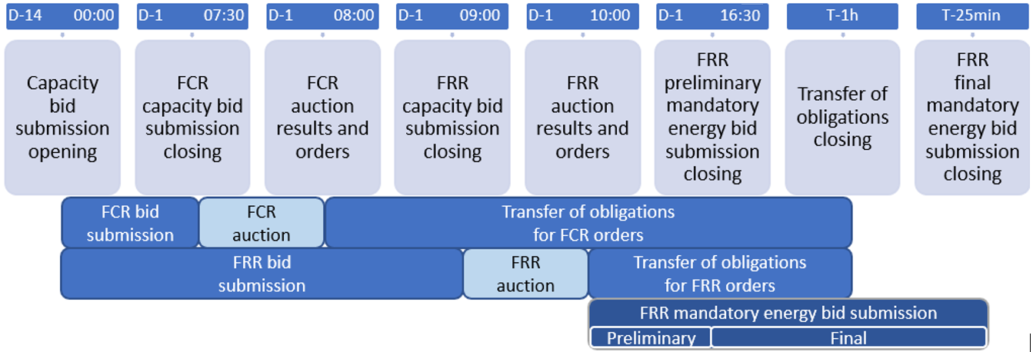
Figure 2. Handling of bids and orders
Orders
As a result of auctions, orders for capacity reserves with obligation for BSP to ensure reserves will be provided. Orders will contain information about the reserve provider, reserve providing unit or reserve providing group, type, amount and price of reserves.
  - Transfer of obligations
After receiving the order for balancing capacity, due to unavailability of resources or other reasons, BSP may transfer obligations provided in the order. Obligations may be transferred until transfer of obligation closing time (Figure 2). aFRR and mFRR capacity obligations may be transferred only within the bidding zone to which the order has been provided. Such restrictions shall only apply until the Exemption to the obligation to allow transfer of aFRR and mFRR balancing capacity for all bidding zones in the Baltic countries (hereinafter – Exemption) in accordance with Article 34(1) of Commission Regulation (EU) 2017/2195 of 23 November 2017 establishing a guideline on electricity balancing is no longer in force. Obligations may be transferred to another reserve unit of the same BSP or to another BSP. In any case, compliance of the BSP and/or reserve unit with prequalification requirements shall be ensured and will be monitored.
  - Additional rules for Mandatory energy bids
FRR reserves specified in the order shall be submitted to the Connecting TSO in the form of respective balancing energy product and in accordance with Baltic balancing rules and corresponding National terms and conditions. Such bids will be considered as mandatory bids in the energy market and there will be monitoring of their presence and availability organised by Connecting TSO.
- Algorithm
There will be separate procurement processes for FCR and FRR. The FCR procurement process is organized before the FRR process which allows the market participants to use the outcome of the FCR process in the FRR process as input. The FCR and FRR processes each have their own individual procurement functions which feature different restrictions. Within the FRR process, the market is cleared simultaneously for both aFRR and both mFRR products, optimizing the CZC usage for all markets.
First the procurement function for FCR is ran and results are communicated to the BSPs. After, the FRR bids are collected and procurement function for both aFRR and mFRR is run as a single optimisation, results will be communicated to the BSPs as stated in the Figure 2.
  - FCR process
The reserve capacity bid closure time for the submission of FCR bids by BSPs to the connecting TSO for the next day shall be no later than 7:30 (EET).

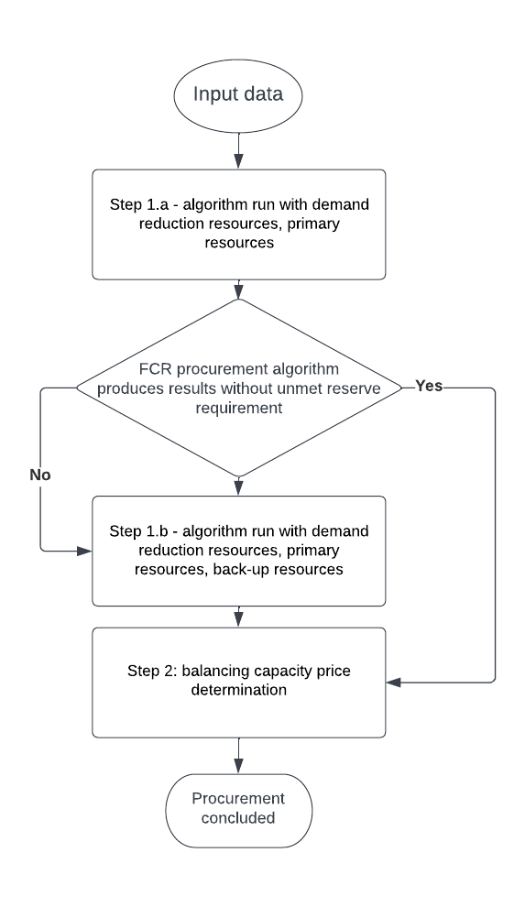
Each TSO shall submit following information as an input to FCR procurement optimization function run:

- all FCR balancing capacity bids received from primary and back-up resources;
- reserve requirements of FCR reserve capacity in accordance with dimensioning rules of the CESA System Frequency working-group;
- minimum volume of balancing capacity to be procured in each bidding zone, if applicable.

Procurement optimization function has Steps (Figure 3): Step 1.a without inclusion of bids marked as back-up resources and if Step 1.a does not satisfy the reserve requirements that was provided by the TSOs, Step 1.b involving back-up bids is run. Step 1.b optimization run shall be considered final, if the algorithm provides results, regardless of fulfilment of TSOs’ reserve requirements. Step 2 determines the balancing capacity price through taking decisions on BC pricing while making sure the pricing principles defined in Article 10 are respected. Price adjustments might be necessary to ensure the minimum required payout for block-bids.
Figure 3. FCR process
Each TSO shall publish the FCR procurement results and submit to respective BSPs the FCR capacity order no later than 8:00 (EET).

  - FCR procurement algorithm
The FCR procurement algorithm shall maximize the welfare of FCR procurement while fulfilling the required FCR capacity reserve requirements in the Baltic bidding zones and in Baltic LFC block. Because no CZC is to be allocated for FCR, in this process the forecast welfare for the exchange of energy is not considered.
  - FRR process
The reserve capacity bid closure time for the submission of mFRR and aFRR capacity bids by BSPs to the connecting TSO for the next day shall be no later than 9:00 (EET).

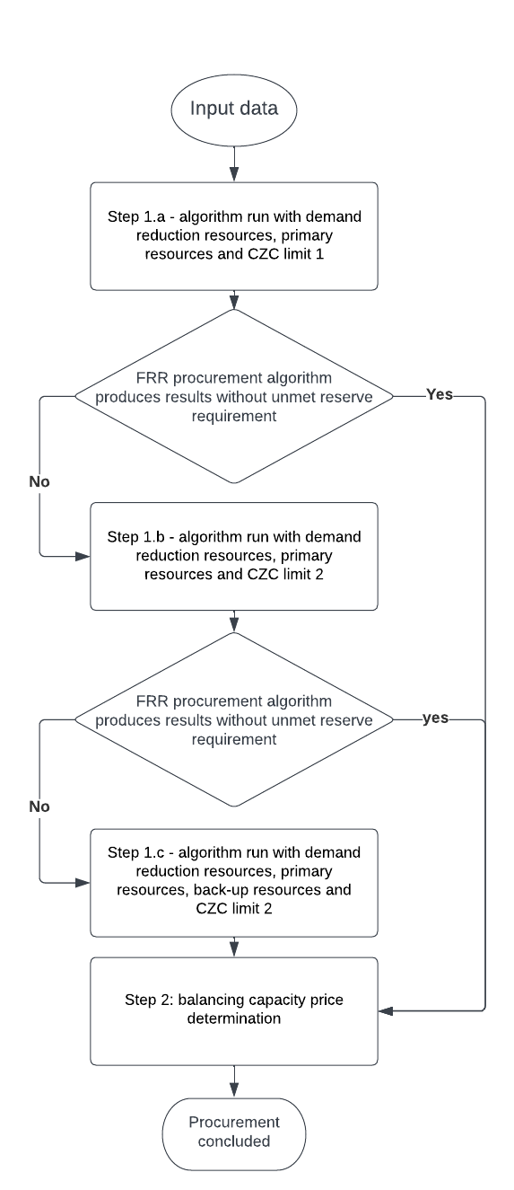
Each TSO shall submit following information as an input to FRR procurement optimization function run:

- all FRR balancing capacity bids received from primary and back-up resources;
- reserve requirements for all 3 Baltic bidding zones: minimal aFRR upward, minimal aFRR downward, total FRR upward, total FRR downward in accordance with dimensioning rules;
- reserve requirements for each Baltic bidding zone: aFRR upward, aFRR downward, total FRR upward, total FRR downward in accordance with dimensioning rules in Baltic LFC block;
- minimum volume of balancing capacity to be procured in each bidding zone, if applicable;
- cross-zonal capacities available for allocation for FRR exchange and sharing in accordance with default and increased percentage limits defined in Article 5(1) of the Methodology for market-based capacity allocation;
- total cross-zonal capacities available for the combination of allocation for FRR exchange and sharing and for the exchange of energy;
- the forecasted market value of cross-zonal capacity for each bidding zone border in the day-ahead market timeframe defined in accordance with the Methodology for market-based capacity allocation.
Procurement optimisation function has two Steps runs as explained in (Figure 4). The first major step is divided into smaller steps, of which the first one is mandatory. The second smaller steps categorized under Step 1 are only executed in case the algorithm has failed to fulfil TSO reserve requirement in the previous steps.
Step 1.a is executed without inclusion of bids marked as back-up resources and application of cross-zonal capacity limits according to default maximum volume of cross-zonal capacity (Limit 1) in accordance with Methodology for market-based capacity allocation.
Figure 4. FRR process
If Step 1.a of the optimization does not provide results that satisfy the reserve requirements which was provided by the TSOs, Step 1.b shall be executed Step 1.b of the algorithm will ensue without inclusion of back-up resources and with application of extension of CZC allocation limit for BC up to the second limit (Limit 2) of maximum volume of cross-zonal capacity in accordance with the Methodology for market-based capacity allocation. In Step 1.b, the cross-zonal capacity is increased in a stepwise manner by increasing Limit 1 by 1% until Limit 2 until the reserve requirements of TSOs are satisfied or the increased maximum cross-zonal capacity limit is reached.
If Step 1.b does not provide the results that satisfy the TSO reserve requirements, then Step 1.c of the algorithm ensues. In Step 1.c algorithm run the bids from back-up resources are included and the procedure of increasing the maximum cross-zonal capacity limit can be used. For the optimization, the cross-zonal capacity is increased in a stepwise manner until the reserve requirement of TSOs is satisfied or the cross-zonal capacity limit is reached. Step 1.c optimization run shall be considered final if the algorithm provides results, regardless of fulfilment of TSOs’ reserve requirement.
Step 2 determines the balancing capacity price through taking decisions on BC pricing while making sure the pricing principles defined in Article 10 are respected. Price adjustments might be necessary to ensure the minimum required payout for block-bids.
Each TSO shall publish the FRR procurement results and submit to respective BSPs the aFRR and mFRR capacity order no later than 10:00 (EET).
  - FRR balancing capacity procurement algorithm
The FRR balancing capacity procurement algorithm shall clear the market simultaneously for the four FRR products: aFRR up, aFRR down, mFRR up and mFRR down; while optimizing CZC allocation for the exchange balancing capacity, sharing of reserves and exchange of energy. The objective of step one of the procurement algorithm shall be the maximization of the combination of forecast welfare on the day-ahead market and the actual welfare of the FRR market. In Step 2, the price of balancing capacity is determined according to the selected bids and allocated CZC.
The mathematical representation of the balancing capacity procurement algorithm is represented in greater detail in the Explanatory document to Baltic CCR TSOs proposal in accordance with Article 41(1) of the Commission Regulation (EU) 2017/2195 of 23 November 2017 establishing a guideline on electricity balancing.
  - CZC allocation for balancing capacity
According to the welfare maximization objective of the algorithm, CZC shall be allocated for balancing capacity if the welfare of using CZC for balancing is higher than forecast welfare for using CZC for the exchange of energy. The mathematical expression of the welfares of the two markets is explained in detail in the Explanatory document to Baltic CCR TSOs proposal in accordance with Article 41(1) of the Commission Regulation (EU) 2017/2195 of 23 November 2017 establishing a guideline on electricity balancing.
- Fallback procedures
The fallback process can be triggered by any one conditions listed in Article 9(1). Due to the completely different nature of possible causes for the reason of going to fallback, several fallback scenarios have been identified. Generally, a joint procurement of balancing capacity in the three Baltic countries is preferred due to efficiency in bid selection. However, such a process can only be used when sufficient time is available to TSOs to prepare for the joint procurement fallback procedure. Additionally, it might be possible that under some conditions the joint procurement algorithm is not able to produce results due to mathematical reasons. In those cases, each TSO shall conduct a separate procurement procedure as is highlighted in Article 9(5).

Fallback according to Article 9(4)
In the joint procurement fallback procedure, the Baltic TSOs aim to replicate the actual auction procedure as close as possible. However, even if joint procurement fallback is initiated, it might be possible that it is not possible to follow all nuances of the Baltic balancing capacity market. For example, publication of data might be delayed if TSOs run the central procurement algorithm in their local systems and must manage the publication procedures manually.

Fallback according to Article 9(5)
The FCR, aFRR and mFRR balancing capacities shall be procured regionally under fallback conditions. The FCR balancing capacity volume shall be procured in each bidding zone as dimensioned for each bidding zone respectively. The aFRR and mFRR balancing capacities in fallback conditions shall be procured in each area based on the required accessible volume and allocated volume of cross-zonal capacity for the exchange balancing capacity or sharing of reserves. The allocated volume of cross-zonal capacity shall be calculated as shown below:

$${ACB}_{LT>LV}=MAX\left({AcV}_{LTdown}-{FRR}_{LTdown};{AcV}_{LVup}-{FRR}_{LVup}\right)$$
$${ACB}_{LV>LT}= MAX\left({AcV}_{LTup}-{FRR}_{LTup};{AcV}_{LVdown}-{FRR}_{LVdown}\right)$$
$${ACB}_{EE>LV}= MAX\left({AcV}_{EEdown}-{FRR}_{EEdown};{AcV}_{LVup}-{FRR}_{LVup}\right)$$
$${ACB}_{LV>EE}= MAX\left({AcV}_{EEup}-{FRR}_{EEup};{AcV}_{LVdown}-{FRR}_{LVdown}\right)$$
Where:
ACB_{i>j} – allocated volume of cross zonal capacity for the exchange of balancing capacity or sharing of reserves direction from area i to area j.
AcV_{i} – accessible volume for area i.
FRR_{i} – distributed FRR balancing capacity volume for the area i in accordance with distribution key, which is calculated.

The same amount of allocated cross-zonal capacity can be used both for upward and downward regulation, hence the larger value is taken. The distributed FRR balancing capacity volume is found by calculating the distribution key for FRR balancing capacity, which is based on the dimensioned aFRR and mFRR volumes for each area, as shown below:

$$c_{aFRR,area}= \frac{{aFRR}_{LFC,area}}{\sum{{aFRR}_{LFC,area}}}$$

$${aFRR}_{area}=c_{aFRR,area}∙{aFRR}_{Baltic}$$

$$c_{mFRR,area}= \frac{{mFRR}_{LFC,area}}{\sum{{mFRR}_{LFC,area}}}$$

$${mFRR}_{area}=c_{mFRR,area}∙{mFRR}_{Baltic}$$
$${FRR}_{area}={aFRR}_{area}+{mFRR}_{area}$$

Where:
c_{aFRR,i} – distribution key of aFRR balancing capacity volume in area i .
c_{mFRR,i} – distribution key of mFRR balancing capacity volume in area i .
aFRR_{Baltic} – aFRR balancing capacity dimensioned for the Baltic bidding zone.
mFRR_{Baltic} – mFRR balancing capacity volume dimensioned for the Baltic bidding zone.
aFRR_{LFC,i} – aFRR balancing capacity volume dimensioned for the area i.
mFRR_{LFC,i} – mFRR balancing capacity volume dimensioned for the area i.
FRR_{LFC,i} – distributed FRR balancing capacity volume for the area i.

The Baltic TSOs shall publish the starting time and the reason for the initiation of fallback procedures. The allocated cross-zonal capacity for the exchange of balancing capacity or sharing of reserves and the procured amount of FCR, aFRR and mFRR shall also be published.

- TSO-BSP settlement
In all of the Baltic bidding zones, the FCR price shall be a single marginal price, as CZC shall not be allocated for FCR and congestion is not possible.
The FRR price is formulated with a marginal pricing principle taking into account two major parameters – the price of the most expensive accepted bid and CZC congestion between bidding zones. In a single bidding zone, or a set of uncongested bidding zones, between which there is balancing capacity exchange or sharing, there shall be a single balancing capacity price per MTU and per balancing capacity product and direction which shall be equal to the most expensive accepted bid in that bidding zone or set of uncongested bidding zones.
In case congestion is detected between bidding zones, the formulated prices can diverge. If the import for a bidding zone is hindered by congestion, the balancing capacity price in that bidding zone shall be taken to be the highest of the following values: the most expensive selected bid cost in that area and the balancing capacity price in the exporting area. This means that the balancing capacity price in the importing area will always be equal to or higher than the balancing capacity price in the exporting area. The definition of congestion is provided in CCR TSOs proposal in accordance with Article 41(1) of the Commission Regulation (EU) 2017/2195 of 23 November 2017 establishing a guideline on electricity balancing.
The rule covering the need to have the same price across uncongested bidding zones is intended to ensure that, where there is a group of uncongested bidding zones, the price in each zone reflects the potential value of investment in additional FRR in each zone as a means of meeting the demand of the other zones in the group. Two examples are presented below that show how the clearing prices are determined. This depends on where the congestion is located and in which direction, and on the most expensive accepted bids in each area.
Example 1. No congestion  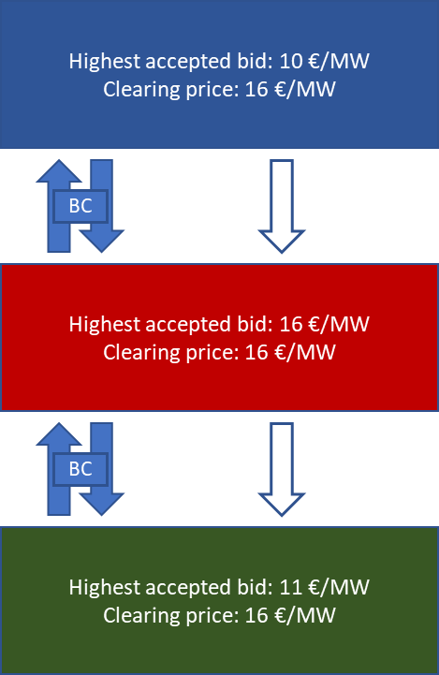  In case no congestion is identified, the clearing price in all bidding zones is equal to the price of the highest priced accepted bid, which is 16 € /MW. | Example 2. Congestion on single border  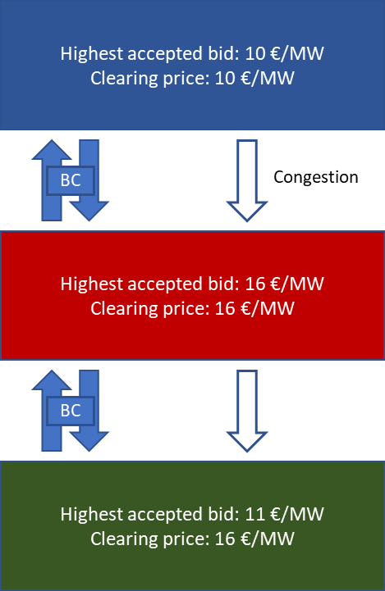  In case of congestion on one of the Baltic borders, the clearing price shall be equal in the bidding zones for which there is no congestion in between, but different for the one bidding zone which is separated by congestion. The two bottom bidding zones will have a price that is the maximum of the highest accepted bid price and the price in the top bidding zone. The clearing price in the top bidding zone will be determined from the highest accepted bid price in that area.

- Congestion income
Congestion revenue shall be generated and shared on bidding zone borders in the directions where congestion is detected and where CZC is allocated for balancing capacity products. The exact rules for generating and sharing congestion revenue are established in Baltic CCR TSOs proposal in accordance with Article 41(1) of the Commission Regulation (EU) 2017/2195 of 23 November 2017 establishing a guideline on electricity balancing.

[Elering website]; [AST website]; [Litgrid website]
[Elering website]; [AST website]; [Litgrid website]
[Elering website]; [AST website]; [Litgrid website]

