Baltic reserve capacity market study

2021 March
Elering AS
AS “Augstsprieguma tīkls”
LITGRID AB

Table of Contents
1. Abbreviations and Definition 3
2. Introduction 4
3. The scope and aim of the study 4
3.1. Baltic LFC block reserve needs 4
4. Methodology for study 5
5. Input data 6
5.2 Input balance and market data 7
5.3. Technical potential and modelling assumption for reserve capacities 13
6. Reserve capacity scenarios 17
7. Reserve capacity market price 19
8. Study results 19
9. Conclusions 28

Abbreviations and Definition
aFRR - Automatically activated Frequency Restoration Reserve
BESS - Battery Energy Storage System
CESA - Continental Europe Synchronous Area
ENTSO-E - European Network of Transmission System Operators for Electricity
FCR - Frequency Containment Reserve
FRR - Frequency Restoration Reserve
HP – High Price scenario
LFC - Load Frequency Control
LP – Low Price scenario
IR - The Investment Request of the Baltic synchronization project phase II
mFRR - Manually activated Frequency Restoration Reserve
NRA – National Regulatory Authorities
NT – National Trends scenario
SAFA - Synchronous Area Framework Agreements
TSO - Transmission System Operator
TYNDP – Ten Year Network Development Plan
MOP – Maximum Operation Power
IPS/UPS - Integrated Power System/Unified Power System of Russia

Introduction
Taking into consideration the Baltic desynchronization of IPS/UPS synchronous area and synchronization to CESA the TSOs of Baltic States shall have to follow and start operating LFC processes required by the Continental Europe SAFA.
Taking into consideration no balancing capacity market has been established in the Baltic States and the offer of balancing services has not been developed, especially in the field of FCR and aFRR, Latvian and Lithuanian TSOs included also BESS in the IR for stable and secure synchronized operations with Continental Europe network, that will support the service of FCR and FRR in a synchronization process with Continental Europe network. Baltic states NRAs are in a position, that the transparent and non-discriminatory market test with standard technical requirements and level playing field in each country must be carried out with relevant market participants not limited within a single country’s boundaries. The Market test study includes prefeasibility analysis aiming to develop possible scenarios for the year 2025.

The scope and aim of the study
The aim of the Market test study is to assess the feasibility and economic impact of provision of FCR and FRR.
Baltic TSOs perform FCR and FRR balancing capacity market test study (hereinafter - study) with following objective:
- evaluate potential of FCR and FRR balancing capacities if it is theoretically feasible to ensure sufficient FCR and FRR reserves to meet the needs of each LFC area separately and in common Baltic LFC block:
a) without exchange of balancing capacities;
b) with exchange of balancing capacities within Baltic LFC block;
c) with exchange of balancing capacities within Baltic LFC block and with possible exchanging with neighbouring LFC blocks.
- the potential cost to each LFC area for procurement of required reserves in each scenario.
Prefeasibility analysis was performed by using ENTSO-E TYNDP 2030 data the power system of the Baltic countries in forward-looking scenario and quantitatively assessing the feasibility and economic impact of FCR and FRR procurement under different conditions.

Baltic LFC block reserve needs
According LFC concept document following reserve needs have been used:
 | FCR | aFRR |  | mFRR
 | +/-, MW | UP, MW | DOWN, MW | UP, MW | DOWN, MW
EE | 8 | 40 | 40 | 209 | 257
LV | 8 | 30 | 30 | 145 | 37
LT | 9 | 60 | 60 | 226 | 276
Total | 25 | 130 | 130 | 580 | 570

Methodology for study
- Technical limitation and parameters for study are set in accordance with Baltic LFC concept document:
- theoretical ability of generating units or reserve providing groups to provide FCR and FRR reserves in each LFC area;
- the required amount of FCR and FRR reserves for the Baltic LFC block and for each LFC area;
- limits for exchange with FCR and FRR reserves within LFC block;
- limits for exchange with FCR and FRR reserves outside LFC block;
- available cross-zonal capacities for exchange of FCR and FRR reserves outside Baltic LFC block.
- Possible provisioning of the amount of FCR and FRR reserves per reserve-providing unit or reserve-providing group.
- Market data for potential FCR and FRR balancing capacity bids:
- Volume (MW) – is equal to theoretical ability of generating units or reserve providing groups
- Price (EUR/MWh) – is evaluated based on cost-based method
- Market simulation method:
- Market simulation consider all technical limitations and parameters and market data;
- Balancing Market clearing is simulated with objective function to minimize the procurement costs;
- Marginal Balancing capacity price method is applied for market simulation.
- Minimum requirements implemented in 2025-2030 ENTSO-E data adopted for the market simulation are the following:
- Performing calculation over a period of one year, with an hourly time discretization
- Modelling of technical constraints which characterize providers of FCR and FRR
- Input data and assumptions are the following:
- the forecasted amount of required reserves for common LFC block in each LFC area (FCR, FRR – aFRR, mFRR) according LFC concept document;
- a List of generators for the provision of frequency control services;
- FCR and FRR reserves limits per reserve-providing unit or reserve-providing group;
- FCR and FRR reserves limits for the sharing within Baltic LFC block and minimum amount of LFC area reserve obligation;
- FCR and FRR reserves limits for the sharing outside the Baltic LFC block;
- Information about the power system evolution according to target year 2030. This input will be based on the following ENTSO-E data for each Baltic country:
- Generation costs (Fuel costs, efficiency, CO2 emission costs);
- Hourly profiles of:
- Generator units or reserve providing group
- Hourly import-export profiles on all Baltic country borders as a result of ENTSO-E Pan-European market simulations in 2025-2030
- Output data are the following:
- required and the theoretical ability of each LFC area to provide the FCR and FRR reserves capacities on hourly basis throughout the year (MW):
- without the N-1 criterion
- Considering the N-1 criterion (disconnection of the largest provisioning unit)
- the potential cost to each LFC area of providing the total required reserves, compared to reserve costs incurred today
- required and the theoretical ability of Baltic LFC block to provide the FCR and FRR reserves capacities on hourly basis throughout the year (MW):
- without the N-1 criterion
- Considering the N-1 criterion (disconnection of the largest provisioning unit)
- the potential cost to each LFC area of providing the total required reserves compared to reserve costs incurred today and with first scenario;
- required and the theoretical ability of Baltic LFC block to provide the FCR and FRR reserves capacities on hourly basis throughout the year (MW) by exchanging with balancing capacities with neighbouring LFC blocks
- without the N-1 criterion
- Considering the N-1 criterion (disconnection of the largest provisioning unit)
- the potential cost to each LFC area of providing the total required reserves compared to reserve costs incurred today and with second scenario.

Input data
  - Description of the selected Market test scenario
For the Baltic reserve capacity market test study was selected ENTSO-E Best Estimate 2030 Scenario (TYNDP 2020 link: https://tyndp.entsoe.eu/maps-data) due to more accurately reflection the cross-border interconnection capacity of the Baltic States and the state of potential electricity generating sources after desynchronization from IPS/UPS.
The TYNDP scenarios include a “Best Estimate” scenario for the short and medium term (including a merit order sensitivity between coal and gas in 2020 and 2025). It is on track by 2030 to meet the decarbonization targets set out by the EU.
The Best Estimate scenarios for 2020 and 2025 are based on TSO perspective, reflecting all national and European regulations in place, whilst not conflicting with any of the other scenarios. A sensitivity analysis regarding the merit order of coal and gas in the power sector is included for 2025 following stakeholder input regarding the uncertainty on prices, even in the short term. These are described as 2020 Coal Before Gas (CBG) and 2025 Gas Before Coal (GBC). By 2030, the storylines dictate that gas is before coal in the merit order, driven by prices and the need to reduce emissions.
EUCO2030 Scenario (TYNDP 2020)
External Scenario: Based on EUCO 2030 is a core policy scenario produced by the European Commission. The scenario models the achievement of the 2030 climate and energy targets as agreed by the European Council in 2014 but including an energy efficiency target of 30 %. The ENTSOs both welcome this new collaboration with the European Commission and welcome further cooperation. As part of the European Commission’s (EC) impact assessment work in 2016, EUCO 2030 was a core policy scenario, created using the PRIMES model and the EU Reference Scenario 2016 as a starting point. EUCO2030 scenario was prepared by a consortium led by E3Mlab, hosted at the National Technical University of Athens (NTUA), and including the International Institute for Applied System Analysis (IIASA). Upon assessment from the EC, although no scenario offered a direct comparison. As a result, the scenario created using the input data from EUCO 2030 has replaced Global Climate Action for 2030 within the TYNDP framework. However, the diverse methodologies used for deriving the scenarios may lead to differences in the continuity between this scenario and those that have been internally developed. The ENTSOs will further collaborate with the EC to improve the overall consistency shown within the Scenario Report.

Input balance and market data
National Trends (NT) 2030 Scenario (TYNDP 2020):
National Trends ( NT ) is the central bottom-up scenario in line with the National Energy Climate Plans (NECPs) in accordance with the governance of the energy union and climate action rules, as well as on further national policies and climate targets already stated by the EU member states. Following its fundamental principles, NT is compliant with the EU’s 2030 Climate and Energy Framework ( 32 % renewables, 32.5 % energy efficiency ) and EC 2050 Long-Term Strategy with an agreed climate target of 80–95 % CO₂ reduction compared to 1990 levels. National Trends relies on data provided by the latest submissions of country specific NECPs for 2030 at the freeze date of the data. Where, in particular for 2040, NECPs do not provide sufficient information or necessary granularity, National Trends is based on TSOs’ best knowledge in compliance with national long-term climate and energy strategies.
Summary table for generation in 2030, GWh
 | EE | LV | LT | Baltic
Generation | 8188 | 3931 | 10740 | 22961
Gas | 0 | 1022 | 508 | 1530
Oil shale biofuel | 3352 | 0 | 0 | 3152
Hydro (run of river) | 0 | 1926 | 436 | 2372
Pump storage | 0 | 0 | 856 | 856
Wind onshore | 1868 | 490 | 2483 | 4841
Wind Offshore | 649 | 437 | 2730 | 3816
Solar | 434 | 56 | 847 | 1337
Other renewables | 1074 | 0 | 1660 | 2734
Other non-renewables | 812 | 0 | 1220 | 2032
Balance(-import) | -600 | -4025 | -4549 | -9073
Demand | 8788 | 7956 | 14147 | 30891
Pump storage consumption | 0 | 0 | 1142 | 1142

Scenario hourly data by country can be seen in the Annex.
From the graphs in the Annex can be seen, that data from ENTSO-E TYNDP year 2030 scenario provide results of market-based simulation with hourly resolution of generation operation, as well as hourly marginal costs in each Baltic LFC area (energy market price). These data have been used as "power market outcome" for year 2030.
Information on generation volumes in the market allows estimate amounts of reserves provided by generators without must run needs.
Information on hourly marginal costs allows making correction of must run costs, as at least part of expenses of must run operation (costs of energy generation during must run operation at minimum stable operation power) can be covered by selling energy at the power market.
For all generating units the standard maintenance outage schedule was applied - one calendar month, in order to consider total availability during single year while reflecting different scenarios of longer maintenances which are done in several years and also the forced outages.
Information of economic indicators used in calculations for reserve bids. Data are also taken from ENTSO-E modelling assumptions for TYNDP scenario modelling.
Start-up costs are applied (added to must run costs) if power plant was not activated in previous 8 hours before must run operation.
Gas price for year 2030 – 6.91 €/net GJ.
CO2 price for year 2030 – 28 €/ton.

Technical potential and modelling assumption for reserve capacities
For the purposes to evaluate the technical potential to ensure required reserves within Baltic states possible reserve service provision was evaluated from existing generation units that are planned to be operational in 2025. Baltic TSOs expect that during public consultation of this study market participants, would be free to submit additional estimation on possible new projects with reserve resource provision, such as Demand side response, storage facilities and etc., to be completed until 2025 and ready for provision of reserve capacities for Baltic LFC block.
1) for EE LFC area
Technical details of power plants participating in coverage of reserve needs from Estonian LFC block:
Name of power plant | Minimum stable operation power, MW | Maximum operation power (MOP), MW | FCR potential (up/down), MW | AFRR potential (up), MW | MFRR potential (up), MW | Comments
Auvere PP | 100 | 274 | 5% of MOP | ramp-up capacity in 5 min | ramp-up capacity in 12,5 min | ramp-up speed is considered as confidential data
Eesti PP | 80 | 194
Balti PP | 80 | 192
Kiisa PP | 10 | 250 | - | - | 250 | Emergency power plant has limitations which are described below

Assumptions were made that Kiisa PP it is used to provide mFRR up in both 1st and 2nd local scenario. On the 3rd scenario, Kiisa is as a last resort to provide reserves, if it is possible for any other PP to provide reserves then the later should always be set a priority.
When modelling Kiisa power plant for providing reserves following assumptions have been made:
- Kiisa PP does not participate in the market and that is why it is usually not generating and thus unable to offer FCR reserves. Theoretically, it is able to do so when it has been turned on to provide emergency reserves, but in this study this situation should not be modelled.
- Kiisa powerplant is made up of generators close to 10 MW each, these generators can be operated individually meaning that the minimum stable operation level can be considered to be just one generator and thus 10 MW. These generators can also be maintained individually so instead of one month-long planned maintenance period, Kiisa would have small capacity reduction during several maintenance periods.
- As Kiisa PP main task is to react fast to a possible emergency, the entire plant is able to go from 0 to 250 MW in around 10 minutes and is thus able to provide 250 MW mFRR upward regulation. mFRR up is also the reserve type that is preferred for Kiisa because of its limitations to participate in the energy market.
Another simplification that was made for this modelling test was that smaller RES and OTHER NON-RES power plants that can be seen from the market dispatch graph are not providing reserves (see graph in chapter 5.2). This simplification was made because the contribution of these plants would be small, however, it would significantly complicate the study.
In scenario 2 “local must run scenario” it was assumed that providing reserves was the priority and power plants would operate their power output according to the need of reserves. It was assumed that:
- All the power plants are run with optimal power output setpoint to provide the maximum reserve coverage;
- Kiisa would provide majority of the mFRR up.
2) for LV LFC area
Following power plants have been participating in coverage of reserve needs from Latvian LFC area:
- Plavinas HPP;
- Kegums HPP;
- Riga HPP;
- Riga CHP-2 (Riga TEC-2).
It shall be noted that all above mentioned power plants have been providing reserves under power market conditions (ENTSO-E TYNDP target year 2030 scenario), but only Riga CHP-2 has been participating in must run cost calculations from Latvia LFC block.
Distribution of generation volumes among HPPs in Latvian LFC block has been made on the basis of historical generation proportion of the HPs and taking into account technical generation possibilities of HPPs (number of generators and their minimum and maximum generation power). Generation data of Riga CHP-2 has been taken directly from ENTSO-E TYNDP target year 2030 scenario data. It shall be noted, that in some hours, generation of Riga CHP-2 has been smaller than minimum stable operation power (180MW) – therefore for such hour's generation of Riga CHP-2 in the market was not taken into account (generation was assumed to be 0MW).
Knowing generation distribution of each power plant in Latvia LFC block area under market conditions, as well as reserve provision possibilities by each power plant (technical data provided in the following chapter), calculation of reserves provided by power plants operating in the power market has been performed - by each power plant individually, as well as in total by LFC area.
Remaining free capacity (controllable generators, not operating according to power market results and not in an outage state) can be used for increasing reserves availability – by requiring generator's operation in must run mode. Calculation of must run generation in LFC area is performed twice: a) activating must run generation with the aim to cover only LFC area's shortage of reserves – if specific LFC area's generators operating in the market don't cover specific LFC area's needs in reserves; b) activating must run generation with the aim to cover shortage of reserves on wider area – all three Baltic LFC areas, if all generators of Baltic LFC areas operating in the market don't cover Baltic LFC areas' total need in reserves. In the first case only, technical availability of reserves is checked, but in the second case also costs of additional reserves (in addition to reserves available from generators operating in the market) ensuring is evaluated. In both cases, first of all, there is need to analyse possibilities of must run power plants to provide reserves – using technical information of generators regarding operational power, reserve provision possibilities and information on outages (in order to take into account unavailability of generators in real life).
Technical details of power plants participating in coverage of reserve needs from Latvian LFC area:
Name of power plant | Minimum stable operation power, MW | Maximum operation power | FCR potential (up/down), MW | AFRR potential (up), MW | MFRR potential (up), MW | Comments
Plavinas HPP | 85 | 95 | 5MW technical capabilities | 5MW  technical capabilities | ramp up capacity in 12,5 min | Data given per generator. 10 generators in total.
Kegums HPP | 7/15 | 18/64 | 1.4/5 MW technical capabilities | 5/20MW technical capabilities | ramp up capacity in 12,5 min | Data given per generator. 4 generators with power of 18MW and 3 generators with power of 64MW.
Riga HPP | 5 | 67 | 5MW technical capabilities | 20MW technical capabilities | ramp up capacity in 12,5 min | Data given per generator. 6 generators.
Riga CHP-2 (Riga TEC-2) | 180 | 425 | 10% of MOP | 12% of MOP | ramp up capacity in 12,5 min | Data given per block. 2 blocks.

- Total number of hours with one Riga CHP-2 one block outage during calculations is assumed to be 102 days during calculation period (year). The value of total outage duration is based on analysis of historical outage durations of Riga CHP-2 blocks for LT LFC area
Technical details of power plants participating in coverage of reserve needs from Lithuanian LFC area:
Name of power plant | Minimum stable operation power, MW | Maximum operation power | FCR potential (up/down), MW | aFRR potential (up), MW | mFRR potential (up), MW | Comments
Lithuanian power plant CCGT (block 9) | 160 | 445 | 5% of MOP | ramp-up capacity in 5 min | ramp-up capacity in 12,5 min
Lithuanian power plant (block 7) | 125 | 225 | 5% of MOP | 0 | ramp-up capacity in 12,5 min
Lithuanian power plant (block 8) | 125 | 225 | 5% of MOP | 0 | ramp-up capacity in 12,5 min
Panevėžys power plant | - | - | 5% of MOP | 0 | ramp-up capacity in 12,5 min | Not considered in must run calculations
Kaunas hydro power plant | - | - | 0 | ramp-up capacity in 12,5 min |  | Not considered in must run calculations
Kruonio HPSPP | 160 | 220 | 0 | ramp-up capacity in 5 min on operating unit | ramp-up capacity in 12,5 min² | Total four units.  Single unit is considered for must run calculations.
Mažeikiai power plant (single unit) | 20 | 70 | 5% of MOP | 0 | 25 | Single unit is considered for must run calculations
Other and Industrial power plants | - | - | 5 | - | - | Not considered in must run calculations
1 - Theoretical potential of Kaunas hydro power plant to provide FRR was evaluated taking into historical data of water inflow.
2 –aFRR service was evaluated for single unit in generation mode. Maximum two units in generator mode were considered to provide aFRR service. mFRR potential depends on available units that are not in the energy market. Maximum four units were considered to provide mFRR service.
Maintenance of generating units were evaluated considering the long term historical emergency outages and maintenance schedules.

Reserve capacity scenarios
The applied calculation methodology has following steps:
- 1 scenario – “Local energy market scenario”: calculation of reserves provision volumes by generators operating according to power market (ENTSO-E TYNDP target year 2030 scenario) and reserve availability hours (in % of all year hours) by LFC area and in Baltic LFC areas in total, and shortage of reserves (volumes) in Baltics in total;
- 2 scenario – “Local must run scenario”: calculation of reserves provision volumes by generators operating according to power market (ENTSO-E TYNDP target year 2030 scenario) and with addition of must run generators, which do not generate on day-ahead market, located in each LFC area (with the aim to cover each individual LFC area needs in reserves), and reserve availability hours (in % of all year hours) by LFC area and in Baltic LFC areas in total;
- 3 scenario – “Baltic reserve market scenario”: calculation of must run generation costs on three Baltic LFC areas in common and total volumes of reserves shortage in Baltic LFC areas in total;
- 4 scenario - “Baltic reserve market scenario with balancing possibility of HVDC connections”: calculation of must run generation costs on three Baltic LFC areas in common and total volumes of reserves shortage in Baltic LFC areas in total if part of FRR reserve needs can be exchanged via HVDC connections in accordance with EBGL Article 41 by applying methodology for market-based allocation process.
- 5 scenario - “Baltic reserve market scenario with FCR cooperation and balancing possibility of HVDC connections”: calculation of must run generation costs on three Baltic LFC areas in common and total volumes of reserves shortage in Baltic LFC areas in total if FCR reserves can be exchanged via Lithuanian-Poland interconnection and part of FRR reserve needs can be exchanged via HVDC connections in accordance with EBGL Article 41 by applying methodology for market-based allocation process;
- 6 scenario - “Baltic reserve technical scenario with not typically long outage of one major generating unit”: calculation of total volumes of reserves shortage in Baltic LFC areas in total if one of major generator units has not typically long outage time. Non-typical outage lasting up to 7 months was simulated for generating units of Riga TEC2 and Lithuanian CCGT separately.
The first two scenarios (steps "a" and "b") have been performed to evaluate technical possibility of each LFC area to cover reserve needs. Also results of scenario "a" (volumes of reserves shortage) have been used as input data for must run generation costs calculation at Baltic level (scenarios "c" to ”f”). In scenarios "c" to “f” must run generators are activated only at those hours and with only those reserve types and amounts, which are still missing on Baltic LFC areas level after utilization of all reserves possibilities from generators operating at power market. At scenarios "c" to “f” must run generation is activated in all three Baltic LFC areas on the basis of "least costs of minimum stable operation" criteria of reserves providing generator and with the aim to cover shortage of reserves in all three LFC areas. "Least costs of minimum stable operation" criteria means that generator with the smallest costs of minimum stable operation (calculated as generation costs multiplied with minimum stable operation power) is activated fist, but with the highest costs – the last. After each bid activation in respective hour, remaining amount of missing reserves is calculated and if it greater than 0 (zero), next bid is activated. The process end when all reserve needs are covered or all bids have been activated.
Calculations considered technical limitations and economic indicators of generators. Technical limitations are the following: minimum stable operation power, maximum possible generation, maximum possible volume of each reserve type (FCR, aFRR, mFRR). Economic indicators are start-up costs and must run generation costs. Start-up costs consist of start-up fuel costs and start-up wear costs. Start-up costs are applied only for those hours, previous to which generator has not been operation some pre-defined number of hours. Must run generation costs calculated based on fuel consumption, fuel costs, CO2 emissions, CO2 emission costs, variable operational and maintenance costs. Technical and economic data have been taken per generator type individually. Must run costs of generator (per MW per hour) are reduced by marginal costs in the respective LFC area in the respective hour, as it is assumed that generator can sell extra power in the power market and get additional income. Therefore, TSOs should pay only extra costs related to generation, which cannot be covered from activities at power market.
In step "c" must run generation bids also take into account outages of generation units basis from real life operation – it means that bids of generators are provided for must run activation possibility for respective hour only when generator is not operating in the market in the respective hour and there are certain amount of hours (based on yearly historical data) at which the generator is not operating in the market, nor providing bids for must run generation.

Reserve capacity market price
For calculations of possible total costs of reserves for TSOs, not only must run costs, but also prices of reserved balancing reserves from ENTSO-E Transparency platform have been used. Croatia, Czech, Hungary, Sweden and Finland data on reserve prices have been taken (average price data per country and reserve type are given in Annex). Data taken of different available “Contract types” (specifying contract time length – e.g. yearly, monthly, weekly, etc) for one-year time period (some data taken from the end of 2019 till end of 2020, but mainly data represent year 2020).
Following resulting price values [Eur/MW/ISP] have been used:
 | FCR | aFRR |  | mFRR
 |  | Up | down | up | down
Minimum | 6.48 | 12.80 | 8.32 | 2.80 | 5.29
Maximum | 21.63 | 23.20 | 25.58 | 14.37 | 5.29

For further analysis Minimum prices from European reserve capacity markets will be considered as Low-price scenario (LP scenario), and maximum prices – High price scenario (HP scenario).
TSOs assume that some of the must-run costs are theoretically included in the EU reserve capacity market prices. While this is probably the case, it has not been possible for the TSOs to distinguish how much of the must-run costs are included in the capacity prices, and therefore, total cost of reserves is calculated as sum of must-run costs and capacity prices.

Study results
The following results were obtained during the analysis of each scenario on the possibilities to ensure the required FCR and FRR reserve capacities in each LFC area and total Baltic LFC blok.EE LFC area required reserves capacities (MW)

- Results for 1st Scenario – “Local energy market scenario”

FCR reserves:
 | Average available capacity, MW | Required reserve need, MW | Average maintained capacity, MW | Percentage of volume required to be maintained | Percentage of time when reserve is maintained
EE | 32 | 8 | 2,9 | 36% | 36%
LV | 19 | 8 | 7,5 | 93% | 76%
LT | 8 | 9 | 8,2 | 92% | 75%

aFRR Upward reserves:
 | Average available capacity, MW | Required reserve need, MW | Average maintained capacity, MW | Percentage of volume required to be maintained | Percentage of time when reserve is maintained
EE | 13 | 40 | 11,3 | 28% | 20%
LV | 17 | 30 | 13,5 | 45% | 9%
LT | 61 | 60 | 39,1 | 65% | 33%

aFRR Downward reserves:
 | Average available capacity, MW | Required reserve need, MW | Average maintained capacity, MW | Percentage of volume required to be maintained | Percentage of time when reserve is maintained
EE | 29 | 40 | 29,5 | 74% | 74%
LV | 45 | 30 | 24,3 | 81% | 65%
LT | 105 | 60 | 29,8 | 50% | 4%

mFRR Upward reserves:
 | Average available capacity, MW | Required reserve need, MW | Average maintained capacity, MW | Percentage of volume required to be maintained | Percentage of time when reserve is maintained
EE | 260 | 209 | 209,0 | 100% | 100%
LV | 986 | 145 | 145,0 | 100% | 100%
LT | 741 | 226 | 226,0 | 100% | 100%

mFRR Downward reserves:
 | Average available capacity, MW | Required reserve need, MW | Average maintained capacity, MW | Percentage of volume required to be maintained | Percentage of time when reserve is maintained
EE | 126 | 257 | 126,3 | 49% | 0%
LV | 198 | 37 | 36,5 | 99% | 93%
LT | 652 | 276 | 269,4 | 98% | 88%

- FCR reserves could be expected to be covered in significant part in Latvia and Lithuania accordingly 93% and 92% of required capacity, while in Estonia only 36% could be covered in “Local energy market scenario”
- Results of higher availability of aFRR downward reserves than aFRR upward reserves highly depends on market outcome, however it can be noted that required aFRR needs could not be ensured in significant part and time.
- Only mFRR upward reserve could be ensured in full amount with available reserves on generating units considering the market results in “Local energy market scenario”.
- Almost all required mFRR downward reserve capacity could be ensured in Latvia and Lithuania accordingly 99% and 98% of required capacity while in Estonia mFRR downward reserve could not be ensured any hour in full required volume, thus only 49% of required volume could be covered in average.
- Calculation of costs for maintaining the reserve capacities were not performed due to fact that available bids after the market are not sufficient to cover the reserve capacity needs in individual LFC areas in Baltics.

- Results for 2nd Scenario “Local must run”

Possibility to cover remaining insufficient reserve capacity with must run generators locally is provided below in the table:
 | EE LFC area reserves availability check for hours
 | FCR (+ and -) | aFRR up | aFRR down | mFRR up | mFRR down
EE | 100% | 100% | 100% | 82% | 75%
LV | 96% | 93% | 96% | 100% | 99%
LT | 100% | 92% | 64% | 100% | 100%

Must run generation electricity amount and addition costs in each LFC area for the amount of reserve capacity that could be provided.

 | Must run generation, GWh | Must run costs, MEU
EE | 2987 | 43.9
LV | 1646 | 27,1
LT | 1683 | 33,6
Total | 6316 | 104,6

For EE LFC area:
If covering the different reserves would be taken as priority over the day-ahead electricity market and existing power plants would run on a specific power output setpoint, which would enable to minimize reserve shortage, then all of the FCR and aFRR reserves could be held at all hours.
However, insufficient mFRR upward reserve capacity was observed 18% of time with average of 22.5MW and reaching highest values up to 16MW which is 11% of required mFRR upward reserve capacity in EE LFC area.
Insufficient mFRR downward reserve capacity was observed 25% of time with average of 48.4MW and reaching highest values up to 108MW which is 42% of required mFRR downward reserve capacity in EE LFC area.
These extent capacity shortages show that each of these 4 power plants is irreplaceable and whenever there is an outage or planned maintenance, the mFRR reserves cannot be covered.

For LV LFC area:
The insufficient FCR reserve capacity was observed 4% of time with average of 2,35MW and reaching highest value of 8MW which if 100% of required FCR reserve capacity in LV LFC area.
The insufficient aFRR upward reserve capacity was observed 7% of time with average of 18,9MW and reaching highest values up to 30MW which is 100% of required aFRR upward reserve capacity in LV LFC area.
The insufficient aFRR downward reserve capacity was observed 4% of time with average of 19,6MW and reaching highest values up to 28.4MW which is 95% of required aFRR downward reserve capacity in LV LFC area.
The insufficient mFRR downward reserve capacity was observed 1% of time with average of 4.5MW and reaching highest values up to 16MW which is 43% of required mFRR downward reserve capacity in LV LFC area.

For LT LFC area:
The insufficient aFRR upward reserve capacity was observed 8% of time with average of 16,5MW and reaching highest values up to 48MW which is 80% of required aFRR upward reserve capacity in LT LFC area. It shall be highlighted that insufficient of aFRR upward reserve is directly dependent on availability of biggest reserve resource providers.
The insufficient aFRR downward reserve capacity was observed 36% of time with average of 21,2MW and reaching highest values up to 60MW which is 100% of required aFRR downward reserve capacity in LT LFC area. It shall be highlighted that insufficient of aFRR downward reserve is directly dependent on night hours when hydro pump storage power plant unit is operating in pump mode.

- Results for 3rd Scenario “Baltic reserve market scenario “
This scenario can be divided into two sub-scenarios. Firstly it is analysed if merging individual “Local energy market scenarios” would cover common Baltic LFC block required reserve needs:
 | Average available capacity, MW | Required reserve need, MW | Average maintained capacity, MW | Percentage of volume required to be maintained | Percentage of time when reserve is maintained
FCR | 32 | 25 | 22 | 88% | 54%
aFRR UP | 92 | 130 | 81 | 62% | 28%
aFRR Down | 105 | 130 | 94 | 72% | 24%
mFRR UP | 1988 | 580 | 580 | 100% | 100%
mFRR Down | 977 | 570 | 553 | 97% | 89%

Considering only the technical capabilities of market participating power plants across the Baltics would still not cover the necessary reserves. This means that it must be analysed how much would it cost to for power plants to participate in the market regardless of the day-ahead market outcome and would it be enough to cover all the needed reserve demand. | Required reserve need, MW | Average maintained capacity, MW | Percentage of volume required to be maintained | Percentage of time when reserve is maintained
FCR | 25 | 25 | 100% | 100%
aFRR UP | 130 | 129,9 | 99,9% | 99,5%
aFRR Down | 130 | 130 | 100% | 100%
mFRR UP | 580 | 580 | 100% | 100%
mFRR Down | 570 | 570 | 100% | 100%

Evaluation of all available generating units to provide reserve capacities while operating as must run generators allows to ensure Baltic reserve needs in most of the time. Simulation results shows not sufficient aFRR upward reserve capacities for 43 hours during periods when two major generating units (Lithuanian CCGT and Riga TEC) are unavailable for planned maintenance. Insufficient aFRR upward reserves in Baltic states were estimated to vary up to 25MW for Baltic LFC block.
In order to ensure required reserve capacity must run generation amounts reaches in 3,1 TWh per year in Baltic States and would increase the annual generation by 13,5%. Distribution of must run generation amounts between countries is provided in figure below:

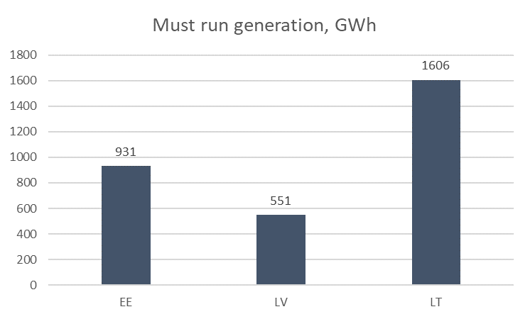

Must run generation total annual costs reaches 67,3 MEUR. Depending on unsatisfied need of reserve capacities FCR aFRR Up, aFRR Down and mFRR Down must run generation costs can be distributed per each reserve time.

Highest share of not satisfied aFRR reserve needs (less than 30% of time) and highest must run costs (17,1+23,7MEUR) for aFRR shows the limited potential in the Baltic balancing capacity market to provide aFRR reserves, thus leading to activation of expensive generation units with must run costs.

Total costs for maintaining reserve capacities were calculated taking into account the must run costs and two scenarios for reserve capacity market prices: Low Price scenario (LP scenario) and High Price scenario (HP scenario). Detailed description of reserve capacity market prices is provided in 7 chapter. For maintaining the required reserves under market prices as described in LP scenario the annual costs reach 66 MEUR, while considering the must run costs and the marginal price effect the total annual costs reach 178MEUR. Distribution of these costs is provided below in the diagram.

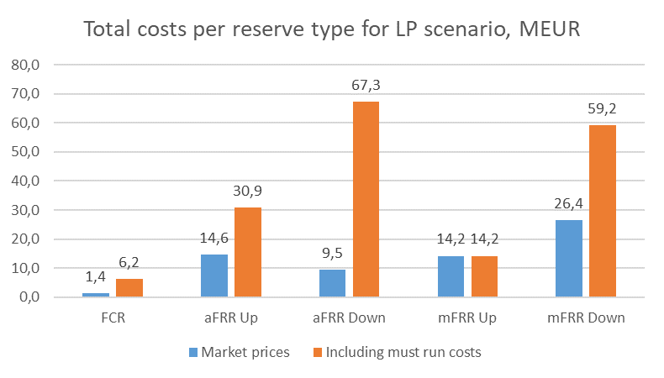

For the HP scenario the annual costs reach 159,7 MEUR, while considering the must run costs and the marginal price effect the total annual costs reaches 246 MEUR. Distribution of these costs is provided below in the diagram.
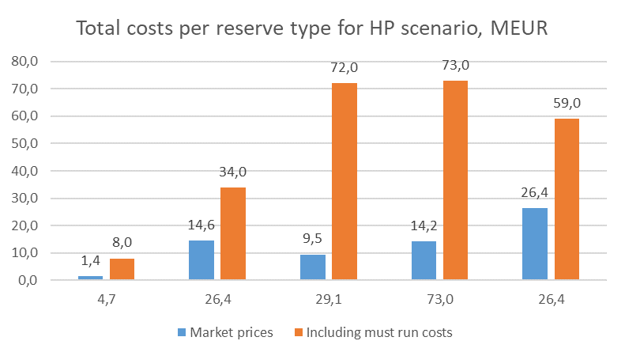

It can be concluded that necessity of must run generation to provide the required reserve capacities results in additional costs 86-111 MEUR per year. In case Baltic reserve market prices are lower than LP scenario, the impact of must run generation marginal costs to determine the marginal reserve market price would become significantly higher.

Total costs for maintaining reserve capacities in Baltic states reaches 178 MEUR in LP scenario and up to 246 MEUR in HP scenario. Distribution of total costs between Baltic countries is provided in figure bellow and is based on required volume of reserve capacities. It shall be noted that cross zonal exchange limitations were not observed therefore no price difference of Balancing capacity markets were evaluated.
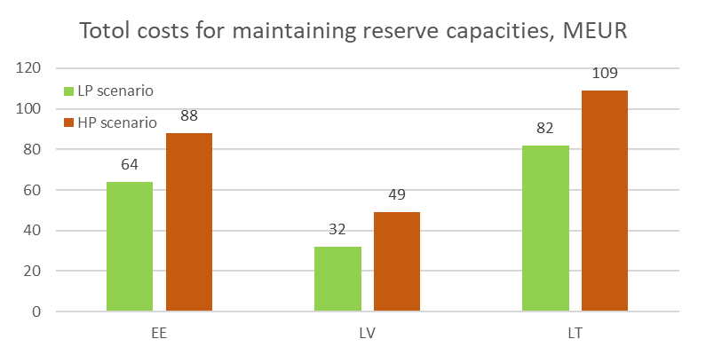

As the must run costs for mFRR downward reserve are highest, additional analysis was made to calculate number of events for each hour of a day when market bids are not sufficient to cover mFRR downward reserve need and volume of required additional bids with must run. Results are provided in the diagram below shows the highest frequency during night hours, while average required mFRR reserve must run bids vary from 30MW at hour 19 up to 199MW at hour 7.

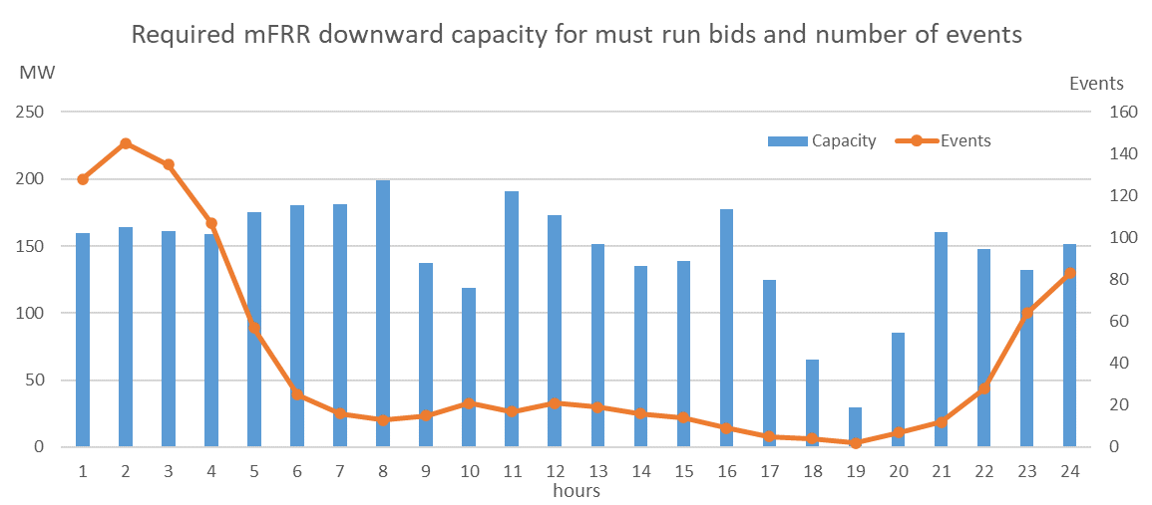

- Results for 4th Scenario “Baltic reserve market scenario with balancing possibility of HVDC connections “

Integration of Baltic Balancing capacity market for aFRR and mFRR with other neighbouring markets in Finland, Sweden, Poland potentially could reduce the must run costs. Estimation of possible 240MW exchange of balancing capacities aFRR and mFRR through the interconnections show that required must run generation would be necessary only to cover missing mFRR downward reserve, therefore must run generation decreases 81% from 3,1TWh till 0,6TWh and must run costs by 90% from 67MEUR till 16,2MEUR. All of the cost decrease would come from aFRR, which in the 3rd scenario was by far the most expensive reserve type- so from this scenario it can be said that having a trade with the neighbouring LFC blocks would be most impactful for the aFRR providers.
As the Must run generation would be required for many hours of FCR and mFRR downward, the marginal price effect of the total costs would reach 166 MEUR in LP scenario, in comparison with 3rd scenario total costs of 178 MEUR. It can be concluded that 16,2 MEUR of additional costs for must run results in 100 MEUR marginal effect for total costs. The increase of total costs when introducing new bids is counter-intuitive, one explanation is that the minimum stable levels for the (last deployed) must run units are so high that to be able to provide any reserves the plants must operate at high power output nevertheless and the cost of that will be allocated mostly to FCR and mFRR.
Comparison of costs between 3rd and 4th scenarios is provided in the table below:

Price scenario | Reserve capacity Scenario | Description of costs | FCR, MEUR | aFRR up, MEUR | aFRR down, MEUR | mFRR up, MEUR | mFRR down, MEUR | Total, MEUR
LP | 3rd | Market prices | 1 | 15 | 9 | 14 | 26 | 66
 |  | including must run | 6 | 31 | 67 | 14 | 59 | 178
 | 4th | including must run | 30 | 15 | 9 | 14 | 98 | 166
HP | 3rd | Market prices | 5 | 26 | 29 | 73 | 26 | 160
 |  | including must run | 8 | 34 | 72 | 73 | 59 | 246
 | 4th | including must run | 32 | 26 | 29 | 73 | 98 | 257

- Results for 5th scenario - “Baltic reserve market scenario with FCR cooperation and balancing possibility of HVDC connections”

Additionally to the 4th scenario the FCR exchange with Poland is considered, therefore in this scenario must run generation would be necessary only for to cover missing mFRR downward reserve. Must run generation decreases till 0,1TWh with total costs of 6,2 MEUR.
As the Must run generation would be required for many hours for mFRR downward, and the marginal price effect the total costs would reach 153 MEUR in LP scenario where 113 MEUR will be allocated only for mFRR downward reserve. It can be concluded that 6,2 MEUR of additional costs for must run results in 87 MEUR marginal effect for total costs.
Comparison of costs between 3rd and 5th scenarios is provided in the table below:

Price scenario | Reserve capacity Scenario | Description of costs | FCR, MEUR | aFRR up, MEUR | aFRR down, MEUR | mFRR up, MEUR | mFRR down, MEUR | Total, MEUR
LP | 3rd | Market prices | 1 | 15 | 9 | 14 | 26 | 66
 |  | including must run | 6 | 31 | 67 | 14 | 59 | 178
 | 5th | including must run | 1 | 15 | 9 | 14 | 113 | 153
HP | 3rd | Market prices | 5 | 26 | 29 | 73 | 26 | 160
 |  | including must run | 8 | 34 | 72 | 73 | 59 | 246
 | 5th | including must run | 5 | 26 | 29 | 73 | 113 | 246

- Results for 6th scenario - “Baltic reserve technical scenario with not typically long outage of one major generating unit

Sensitivity analysis of non typical outage of single major reserve providing units shows that Baltic LFC block is highly dependent on availability of reserve resource providers. Unavailability of single reserve resource provider can result:
- Insufficient volume of aFRR upward was observed up to 20% of time during which the reserve resource provider was unavailable. Average of 23MW during hours when there is insufficient capacity, and reaching up to 95MW
- Insufficient volume of aFRR downward was observed up to 4% of time during which the reserve resource provider was unavailable. Average of 15MW during hours when there is insufficient capacity, and reaching up to 60MW

It can be noted that risk of insufficient aFRR reserve capacity could be mitigated by exchange with neighbouring LFC blocks, that could ensure the missing aFRR capacities.

Conclusions
- Considering market simulation data Estonian, Latvian and Lithuanian power systems individually are not able to maintain required reserve capacities: FCR, aFRR, mFRR downward, whereas only mFRR upward could be maintained. Must run generators are necessary to maintain FCR, aFRR and mFRR, however none of individual power systems can maintain all required reserves.
- Technical potential to maintain FCR and mFRR required reserve capacities within common Baltic LFC block is feasible, however provision of aFRR capacity will not be ensured during all periods. Results of feasible options show that must run generation in each power system will be necessary with annual generation reaching up to 3,1TWh and total annual costs of maintaining FCR and FRR reserves is expected up to 175MEUR (Low price scenario) or 246 MEUR (High price scenario). Indicative distribution of the costs among the individual Baltic TSOs in a low price scenario is as follows: Elering – 64 million EUR, AST – 32 million EUR, Litgrid – 82 million EUR. Indicative distribution of the costs among the individual Baltic TSOs in a high price scenario is as follows: Elering – 88 million EUR, AST – 49 million EUR, Litgrid – 109 million EUR. Aforementioned numbers represent 3rd scenario (“Baltic reserve market scenario”), which doesn't foresee integration of Baltic Balancing capacity market with neighbouring markets
- Modelling results shows that available resources in market are not sufficient to ensure mFRR downward reserve capacity as last resort reserve resource provision from Kiisa power plant would be necessary to ensure required mFRR downward reserve capacity for 14 hours in average of 34,4 MW of reserve capacity.
- Common Baltic LFC block reserve capacity market also allows to reduce must run cost from 104,6 MEUR in 2nd scenario of local markets down to 67,3 MEUR.
- Considering that marginal pricing model will be used for common Baltic LFC reserve capacity market the most expensive bids from the must run generators with costs of 67,3 MEUR would increase the Total costs up to 111 MEUR from the market price level.
- It is expected that BSPs would adjust the usage of assets in the energy market to provide offers for the reserve capacities, however the reserve capacity price additionally to operational and maintenance costs will also include the opportunity costs: not received income from the energy market. Therefore, it is expected that price for the maintaining reserve capacities could increase from the current reserve price level in Baltics to the price level in the other European countries reaching yearly average price up to 12 EUR/MW/h in low price scenario.
- Necessity for must run generation to ensure mFRR downward reserve was observed only during nigh hours when market results included hydro pump storage units in pump mode. During these hours must run generation could be replaced by bids from hydro pump storage unit, however it will significantly reduce the pump mode possibility thus leading to reduction of generation mode during peak load hours and reduction of possibilities to provide aFRR reserve capacity.
- Possible integration of reserve capacity markets with neighbouring areas Finland, Sweden, Poland to exchange reserves through the interconnections could ensure Baltic power system a technical capability to maintain all required reserves on the expense of reducing available interconnection capacity for day-ahead and intra-day energy trade and would significantly decrease the need of must run generation down to 0,6TWh for 4th scenario or 0,1TWh for 5th scenario, however marginal effect of the most expensive reserve bid which sets the marginal price would not be mitigated. Considering complex and uncertain nature integrating two or more regional markets there is a substantial risk that integration of the Baltic, Nordic and Polish reserve capacity markets might not be achieved by 2025.
Sensitivity analysis of non-typical outage of single major reserve providing units shows that Baltic LFC block is highly dependent on availability of reserve resource providers. Unavailability of single reserve resource provider result in the insufficient or even absence of aFRR reserve capabilities in Baltic states.

Annex.
Scenario hourly data by country

Scenario hourly data by country can be seen in the following graphs
Estonia power balance hourly data:
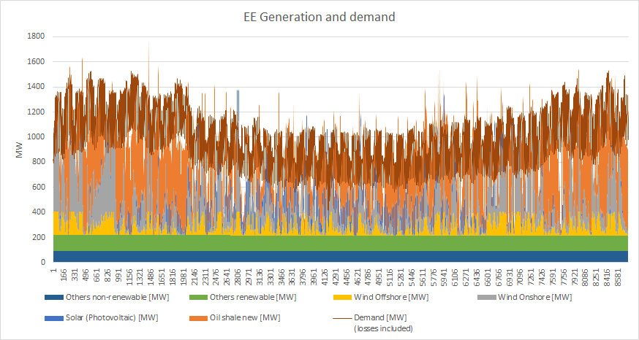

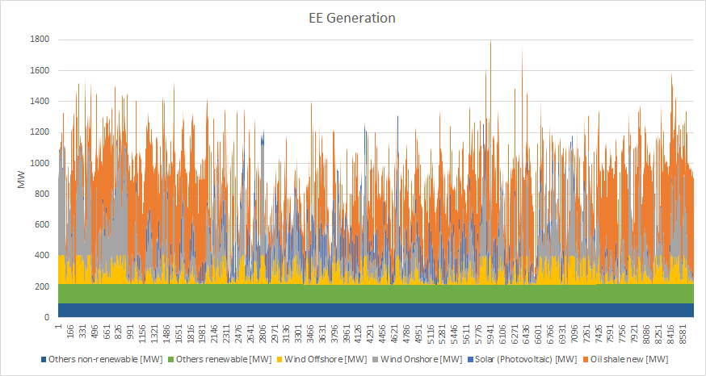

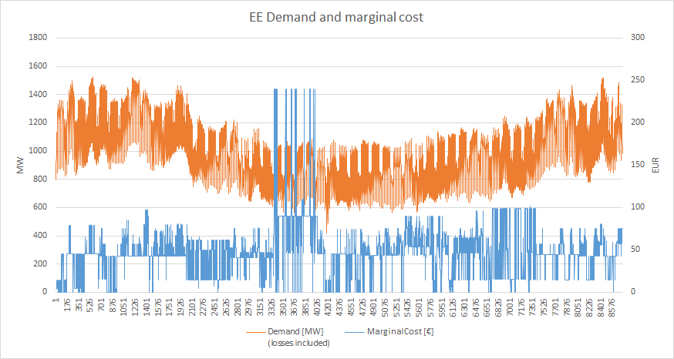

Latvia power system hourly data:
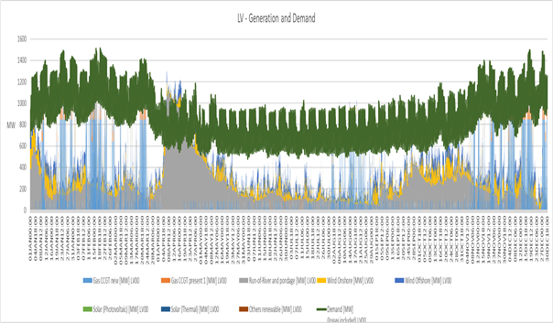

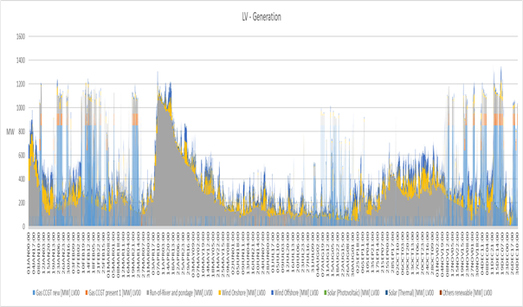

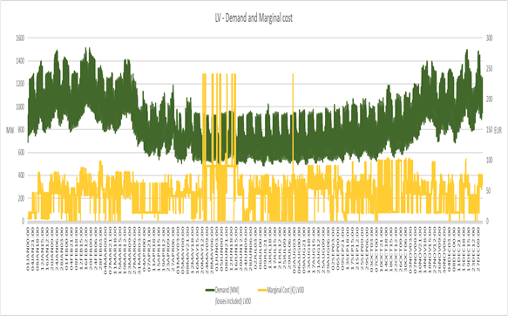

Lithuanian power balance hourly data:
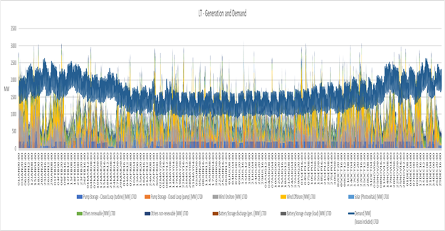

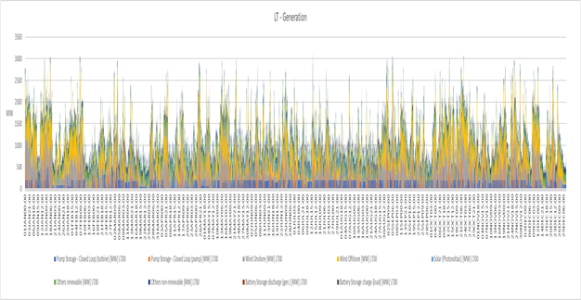

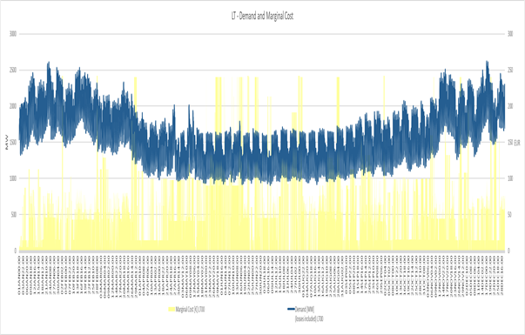

Total Baltic consumption and generation Baltic power balance hourly data:
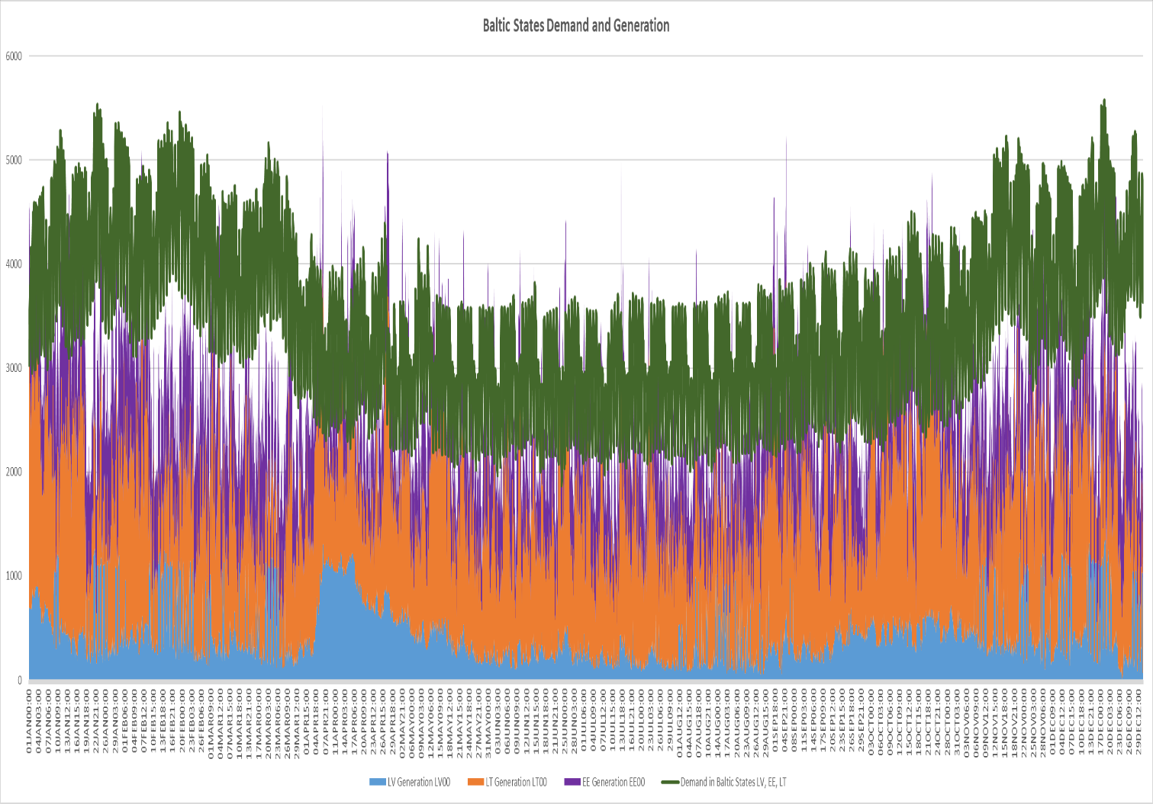

Reserve capacity market price

Average price data per country and reserve type on the basis of “Prices of Procured Balancing Reserves” data from ENTSO-E Transparency platform
 | FCR | aFRR |  | mFRR
 |  | up | down | up | down
Croatia | NA | 12.80 |  | 6.95 | NA
Czech | 19.63 | 13.13 | 9.45 | 14.37 | 5.29
 | 15.10 | 23.20 | 25.58 | NA | NA
Hungary | 13.62 | 16.39 | 8.32 | NA | NA
Sweden | 16.80 | NA | NA | NA | NA
Poland* | 1.27 | 1.29 | NA | NA | NA
Finland | 21.63 | 13.37 | 12.97 | 2.80 | NA
 | 6.48 | NA | NA | NA | NA

* - prices of FCR and aFRR upward markets in Poland was excluded from further analysis of price scenarios due to significant price difference (more than 10 times) from other areas and considering that central dispatch model is applied in Poland.

Price of Reserved Balancing Reserves (Prices of Procured Balancing Reserves [17.1.C]) https://transparency.entsoe.eu/dashboard/show

